

Enterprise Edition

User Guide and Reference



Last update: October 2009
Table of Contents
Pion: A Quick Introduction 4
Pion: What Is It? 4
Pion: What Will It Do For Me? 6
Pion: Architecture 8
The Pion Server 8
Pion Sniffer Placement 9
Using Network Taps and Spans 9
Spanning/Mirroring vs. Taps Comparison 11
Network Communication Channels 11
Other Network Considerations 13
Working with Load Balancers 13
Working with Proxy Servers 13
Pion Security Elements 13
Pion and SSL 14
Configuring MS IIS to Work with Pion 15
High-Volume Pion Implementation Guidelines 15
Pion: The Application 17
Getting Started with Pion 17
Reactor Configuration Page 17
Reactor Types Toolbar 18
The Vocabulary Configuration Page 21
The Codec Configuration Page 23
The Database Configuration Page 25
The Protocol Configuration Page 26
Managing and Configuring Pion 27
User Configuration 27
System Configuration 28
Using the Replay Feature 29
Pion Reactors 35
Important Notes About Reactors 35
Database, Table, and Column Naming Conventions 36
Comparisons 36
Reactor Input and Output Connections 37
Collection Reactors 38
Log File Input Reactor 38
The Connections Section 41
Sniffer Reactor 41
The Captures Section 44
The SSL Servers Section 45
The Connections Section 46
Processing Reactors 47
Aggregate Reactor 47
The Aggregations Section 52
The Connections Section 53
Using the Query Service with the Aggregate Reactor 53
Clickstream Reactor 55
The Session Groups Section 60
The Page Object Detection Section 61
The Sticky Page Fields Section 62
The Sticky Session Fields Section 62
The Connections Section 63
Content Hash Reactor 63
The Inclusion Conditions Section 64
The Connections Section 65
Filter Reactor 65
The Comparisons Section 67
The Connections Section 68
Fission Reactor 68
The Terms to Copy Section 70
The Connections Section 71
Python Reactor 71
About Your Source Code in the Python Reactor 73
The Connections Section 75
Script Reactor 75
The Connections Section 77
Session Filter Reactor 77
The Comparisons Section 80
The Connections Section 81
SQL Reactor 81
The Connections Section 84
Transform Reactor 84
The Transformations Section 87
The Connections Section 89
Storage Reactors 90
Database Output Reactor 90
The Inclusion Conditions Section 93
The Field Mappings Section 94
The Connections Section 95
Google Analytics Reactor 95
The Connections Section 97
Log Output Reactor 97
The Connections Section 98
Multi Database Reactor 99
The Database Tables Section 102
The Connections Section 102
Omniture Analytics Reactor 102
The Queries Section 106
The Connections Section 107

Pion: A Quick Introduction

Pion: What Is It?
Pion is a robust, highly configurable, extremely fast data analytics application, including a server tuned specifically for data acquisition and transformation. The flexibility of Pion's building-blocks architecture allows you to gather data from a wide variety of sources, filter out the parts you don't need, and then keep the useful information. Additionally, Pion allows you to transform the data (or parts of the data) according to rules you specify, and you can store the data for compliance purposes or later review.
Pion has specialized building blocks (called reactors) that you chain together to form a chain that gathers, and transforms data from the sources you choose, and then stores the parts you want to keep.
Pion is passive, in the sense that it does not alter the original data in any way. Pion monitors live data streams or reads log files, then transforms the data as necessary, and finally stores the results or the transformed data, but the original data is not changed in any way.
Pion is standards-based, in that it works and uses with standard protocols, log and data formats, processing libraries, and APIs.
The Pion application is browser-based; and is controlled through a Web Browser. All standard web browsers are supported, but due to implementation differences within the browsers, some Pion features may look different in one browser than they do in another. Pion recommends Mozilla Firefox or Apple Safari for all platforms (note that Google Chrome is not supported).
Pion also provides an XML-based web services API that allows you to do everything the browser-based application does. Documentation for this API is available at our web site:
http://pion.org/projects/pion-platform/documentation/servicesU
To help you understand more about Pion, it will be necessary to define some Pion-specific terms and concepts:
Events
An event is a message that represents any type of action or occurrence. Pion is a real-time platform which enables both simple and complex event processing using pipelines of interconnected plug-ins, called Reactors.
Reactors
A Pion Reactor performs a defined task, and there are many specialized Reactors. Each reactor performs a specific task, and each reactor is specialized for a particular task. A Reactor can be thought of as atomic in the sense in that it is the smallest unit of work. Reactors are the basic building blocks which are chained together to accomplish tasks.
To make organization easy the Reactors are broken down into three basic families by their functions:
- Collection Reactors receive some sort of input (either through monitoring a data stream, an application log, or from a script or another Reactor) and create Events when defined criteria are met.
- Processing Reactors process and/or change Events. Processing Reactors may interact with other systems, for example the SQL Reactor interacts with a SQL Database, such as MySQL.
- Storage Reactors handle the output of one or more Processing Reactors. Depending on the Storage Reactor, the processed Event may be stored in a database or log file, or it may be sent to another application (such as Google Analytics or Omniture Genesis).
Storage Reactors are needed whenever data needs to be persisted for later use for reporting or record keeping. For web analytics to take place, a Pion Workflow must always end with a Storage Reactor.
Reactors of different types are chained to form a complete processing path, starting with data acquisition, and ending with some form of output. For example, when reading a web server log (or even when capturing/monitoring a web server's traffic):
- A Collection Reactor detects an an instance of that server generating a 404 (page not found) error. The Collection Reactor creates an event and sends it to a Processing Reactor.
- The Processing Reactor receives the Event, and strips out everything but the ID of the server that generated the error, the bad URL, the time, the date, and the session ID of the user. The Processing Reactor then passes this Event to another Processing Reactor and to a logging Storage Reactor.
- The second Processing Reactor compares the server ID to a list of server ID and email address pairs, and inserts the email address at the beginning of the Event before sending the Event to an alerting Storage Reactor.
- After receiving the Event from a Processing Reactor, the first Storage Reactor records the information in a log file, and the second Storage Reactor sends an email to the email address in the Event.
In this way, the Reactors receive data, create and process Events, and output the results.
Pion provides an open source platform users or third parties can also create their own Reactors if they need additional functionality without having to modify the core of Pion in any way.
Codec
A Pion Codec defines an input or output format for things like logs, for example CLF (Common Log Format) or ELF (Extended Log Format). A Codec can also define notation such as JSON or XML. Codecs are used by Reactors to 'break' data into chunks that can be recognized or manipulated.
Vocabulary
A Pion vocabulary is a list of terms (and types, such as shortstring, string, longstring, date, uint8, uint16) that form the possible elements of information contained in an event. The most common vocabulary is the Clickstream vocabulary; which is used to describe the Terms in an web page view or HTTP event. Examples of other vocabularies are RSS, Atom, stock prices, and aggregate (see “Vocabulary Configuration“ on page 21, for more information on vocabularies). Users can create new vocabularies, or modify and extend existing vocabularies to meet their needs.
Terms
A Pion term refers to an item within a vocabulary. The term is a way to label a value that is collected or calculated. Events in Pion have a type (that matches an "event type" term such as "urn:vocab:http-event") and may contain zero or more fields, each of which corresponds with a particular term and value.
Requests, Page Views, and Sessions
Within Pion, request events are used to describe individual HTTP requests. A page view event represents an individual web page rendered within a browser window (also sometimes referred to as a "click"), and is usually made up of many HTTP requests. A session event represents a specific visitor session, and usually includes one or more page views.
Workspace
A Pion workspace is a graphical presentation of a group of Pion reactors chained together. Pion allows for multiple workspaces, each of which can contain a self-sustained, parallel-running set of reactors. Pion workspaces are browser-based; that is, thee Pion application is controlled through a Web Browser.
All standard web browsers are supported, but due to implementation differences within the browsers, some Pion features may look different in one browser than they do in another. Pion recommends Mozilla Firefox or Apple Safari for all platforms (note that Google Chrome is not supported).
Other terms and concepts that are important to Pion, but are not Pion-specific. Some are specific to other applications (such as Omniture Genesis or Google Analytics). These terms and concepts are used throughout Pion, and you should know what they mean in order to make sure you understand what Pion does and how to use Pion's features and the related technologies.
Regex
A “regex” or “regexp” (REGular Expression) is a common method of describing a text pattern for filtering, matching or transformation purposes.
Queue Size
Generally used to describe optional Queuing (or grouping) of items. For databases, Queue Size defines the maximum number of events to queue before writing them (in bulk) to a database.
Queue Timeout
Defines the amount of idle time before a queue is written (in bulk) to a database.

Pion: What Will It Do For Me?
Pion will provide you with better information for less effort then you are putting in today with traditional page tags, data warehouses and ETL tools. Pion does this through:
- Capturing the complete conversation between your users and the web backend servers.
- Identify and track individual users across visits.
- Sessionize clickstreams to establish unique behavioral patters.
- Extract critical information and events from the conversation (Totals, Products, Promotions, etc)
- Handle non-browser interactions from RSS and ATOM news services.
- Capture Mobile Phone browsers.
- Eliminate the need for most page tags (90%+ reduction).
- Combining real-time and historical information.
- Collect information from relational databases (Oracle, DB2, MS-SQL, MySQL, Informix, Sybase and more).
- Pull in customer information from ERP and CRM systems.
- Connect to back end log files.
- Provide an merged stream of data from different sources.
- Freeing your data through integration.
- Feed your existing web analytics solution from Omniture, WebTrends, Google Analytics and others.
- Store data in your data warehouse (Oracle, DB2, MS-SQL, MySQL, Teradata and others).
- Feed your existing business intelligence tools (Cognos, Business Objects and others).
- Provide web services streams to real-time applications.
- Replaying customer interactions.
- Provide a visual, page by page representation of what the user saw.
- Expose detailed session information about the user and their environment.
- Report on the performance of the end user experience.
- Provide detailed information on the user submission and server response.

Pion: Architecture
Pion uses a very straight-forward architecture design based on the ability for it to listen to the conversation between the user’s web browsers and the back end servers. When properly placed in the network, Pion is able to both capture the live browser conversation and listen for any active content calls from the browser for purely client-side content (such as videos, music, or files). Capturing data from web log files is easily accomplished from almost any network location with remote file access.
A basic conceptual architectural diagram looks like this:
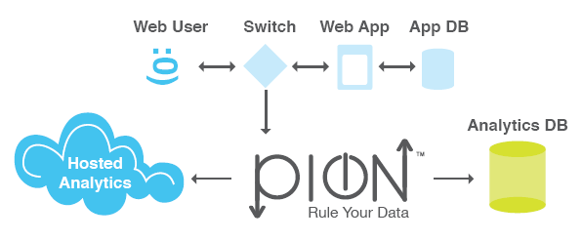
As you can see in the above diagram, Pion is completely passive and in no way impacts the user’s web experience. This is accomplished by using either network tapping or spanning to simply take a copy of the conversation between the web clients and the servers (the data stream). The very nature of a tap/span is a one way conversation; meaning Pion never communicates back with your web site visitors browsers. This ensures that the highest levels of both security and performance are delivered to your web site visitors, because Pion does not interact with the clients browser at all. After the Pion server captures and interprets the user traffic, it communicates with your analytics database. In the case of hosted providers such as Omniture Genesis and Google Analytics, this communication occurs via a web service. For internal analytics packages, this communication is most often performed via a relational database output Reactor or a structured file Reactor.
The critical pieces of this architecture are:
- Pion Server
- Pion Sniffer Reactor placement in your network
- Network communication channels
These, and other topics that affect Pion's operation, are covered in greater detail below.

The Pion Server
The Pion software takes full advantage of the latest commodity hardware available, as well as multiple operating systems. Pion currently supports the following operating systems:
- Linux x86– RedHat EL 4, 5 (32 and 64 bit), CentOS 4,5 (32 and 64 bit)
- Windows – XP, Vista, Windows 2000, Windows 2003 and Windows 2008 (32 bit x86)
- MacOS X – 10.5 Intel (32 bit x86)
Pion will also run on VM Ware, but for product network traffic capture we suggest dedicated hardware. Because VM Ware is known to occasionally drop packets, if you plan on using a Sniffer Reactor to monitor network data, you should not run the Pion server on a VM Ware installation.
Although Pion will run on very minimal hardware it is important to size it appropriately for production applications. The most critical components are CPU and RAM. A good rule of thumb is a 2GHz CPU core and 2GB of RAM are generally able to handle about 100Mbps worth of HTTP(S) traffic with a normal configuration. Because Pion is highly multi-threaded, and it makes very effective use of multiple CPU cores, a single server can scale to handle approximately 1.2 Gbps worth of HTTP(S) traffic.
For sniffing purposes, Pion also needs high quality network interface cards, and we have had great experience with the Intel Pro cards. They aren’t an absolute requirement, but we have seen Broadcom and 3com cards dropping packets for no apparent reason from time to time. It is also important to ensure that you have an extra network interface for server management in addition to the number of ports you’ll need available for sniffing traffic.

Pion Sniffer Placement
The first step in designing the architecture is to determine where the best place is to capture your network data. Ideally Pion would only capture the traffic you want it to see and nothing else. Therefore, the best place to place to tap/span is often very close to the web servers. This allows us to minimize both the amount of “garbage” traffic we see, and reduce the amount of network listening we need to do. Fortunately, most networks are hierarchical in their design. The hierarchy is usually made up of “server” switches (sometime referred to as “server farms”, “farm switches”, “edge switches” or similar) and “aggregation switches”. As their names suggest “server” switches connect servers to switches while “aggregation” ones connect “server” switches to each other. Because of this it is often possible to monitor even very large data centers with one or two network listening points.

Using Network Taps and Spans
In order for the Pion to passively capture user traffic it must receive a duplicate stream of traffic to analyze. There are 2 methods to implement this:
- Spanning/mirroring, which is implemented by configuring the switch to duplicate a stream of traffic from one port(s) to another. You connect one of the sniffing NIC(s) on the Pion server to the physical port(s) on the switch to which the duplicate stream is sent.
- Network taps, which fall into several categories depending on their configuration.
- Basic Network Taps, which are device with typically one set of inputs (transmit and receive) to one set of outputs (transmit and receive) similar to your standard stereo splitter as shown:

- Regeneration Taps, which have a set of inputs (transmit and receive) and are able to send the same output to multiple transmit and receive ports allowing multiple devices to evaluate the same traffic as shown below:

- Aggregation Taps, which are able to take in multiple sources of traffic and combine that traffic so that it can be consumed for one monitoring device as illustrated in the picture below:

Spanning/Mirroring vs. Taps Comparison

Factor | Span/Mirror | Tap
Description | Using the software in network device to copy traffic from one or many ports to another | An “in stream” device that passively copies traffic to another source, like a stereo splitter
Type | Software configuration | Hardware device
Cost | None. Implemented in software on the switch | Varies by vendor and type of device but usually low
Scalability | Limited. Each switch has a limited number that can be implemented | Unlimited
Flexibility | May allow you to filter the traffic | None. All traffic is duplicated
Quality | Under high loads switch may drop packets | Always a clear signal and copy
Installation | On-the-fly, no downtime | Requires cabling and may also require switch downtime

Network Communication Channels
Pion must be able to communicate in order to be effective. To manage Pion you’ll want to have at least one secure channel to the web server or terminal.
Management Channels | Port | Protocol | Direction
Secure command line management | 22 | SSH | User → Pion
Web administration | Any, default is 8888 | HTTP(S) | User → Pion
Windows Terminal Services | Any, default is 3389 | RDP | User → Pion
Pion must also have network access to write the data you want to the desired location. This can occur over any port you define. The common ones and their defaults are listed below.
Data Output Channels | Port | Protocol | Direction
Omniture Genesis Web Services | 80/443 | HTTP(S) | Pion → Omniture
Google Analytics Web Services | 80/443 | HTTP(S) | Pion → Google
Oracle Database Server | Any, default is 1521 | OCI | Pion → DB
Microsoft SQL Server | Any, default is 1433 | DB-Lib, OLE-DB | Pion → DB
Sybase | Any | Open Client, ASE or ASA | Pion → DB
DB2 | Any, default is 50000 or 446 | DB2 CLI | Pion → DB
MySQL Enterprise | Any, default is 3306 | MySQL CAPI | Pion → DB
ODBC | Any | ODBC | Pion → DB
Informix | Any, default is 1526 | Informix CLI | Pion → DB
Interbase/Firebird | Any | Native | Pion → DB
Centura/Gupta SQLBase | Any | CAPI | Pion → DB
PostgreSQL | Any | Libpq | Pion → DB
SQLite | Local | Local | Pion → DB

Other Network Considerations

Working with Load Balancers
Load balancers are very common in enterprise environments. In most cases they present a complication when it comes to Sniffer Reactor placement because they perform what is known as Network Address Translation or NAT. When a load balancer receives a request from a user, it determines which server will receive the request, then opens a connection to this server and forwards the request, replacing the user’s IP address with its own. This results in a situation where users always see the load balancer as the destination and servers always see the load balancer as the source. Based on whether the sniffer is listening to traffic “before” the load balancer (between the client and the load balancer) or “after” the load balancer (between the load balancer and the servers), Pion may lose its ability to link the client to the specific server if this situation is not addressed. Two easy solutions exist to handle load balancers:
- Using the X-Forwarded-For (XFF) tag. This solution is very simple, and often requires little or no effort because it is built into almost all modern load balancers and is set to work by default. The X-Forwarded-For (XFF) tag is the unofficial standard for identifying the originating IP address of a client connecting to a web server through an HTTP proxy. Most load balancers have it turned on by default, and those that don’t often allow you to enable XFF easily. By default, if the XFF is used, it is interpreted by Pion as the original IP tag. This means that it is very likely that you won’t have to do anything. You can read more about XFF on http://en.wikipedia.org/wiki/X-Forwarded-For and http://meta.wikimedia.org/wiki/XFF_project.
- Having a Pion Reactor extract client session information directly. This solution requires a little more effort, but is more flexible. Since Pion sees all of the traffic, it doesn’t have to rely on the network data and Pion can extract the content from the user session. Therefore, Pion can easily identify and track people by user name, host name, session ID, cookies or anything else that is communicated with the server.

Working with Proxy Servers
Proxy servers, while very different in function than load balancers, have similar implications due to the fact that they also implement NAT. There are a few additional issue to contend with when dealing with proxy servers.
- Unlike load balancers, which only re-write the host address, proxy servers often re-write the URL (or more accurately the URI). If this is the case, Pion may need to be configured to reconstruct the original URI with the Transform Reactor.
- Proxy servers may implement an additional caching mechanism that doesn’t follow normal browser caching rules. Rather than retrieve all resources from the server for each user request they cache resources (typically static resources such as graphics, entire static pages, rich media, etc.) locally. This means that you may have to place the Pion sniffer before the proxy server to ensure you get all of the calls.
- Proxy servers are not traditionally considered part of the network architecture. Therefore, they are not always present on network diagrams. You should find out if they are part of the network environment.

Pion Security Elements
Since Pion captures real user behavior by listening to the conversation that occurs between your web users (customers) and the infrastructure you use to deliver their online experience, it is reasonable to be concerned about what happens to this conversation. Pion takes great pains at every step of the way to ensure the security of the information it touches using a variety of techniques:
- One-way communication for the Pion Sniffer Reactor. The Pion Sniffer Reactor cannot communicate with anything other than the Pion server application under any circumstances. It is completely passive and is only fed one-way traffic. Because of this, Pion is more secure than any of the web servers it is listening to because it cannot communicate.
- Extra security layers for SSL keys. Pion often needs to decrypt information on the fly for interpretation and as such requires the critical private SSL keys. These sensitive keys can be kept securely under additional layers of encryption and password protection to ensure safety on top of the network layer security previously mentioned.
- Filtering/masking of sensitive information. Once the user and network data is inside of Pion, you can have Pion filter out or translate sensitive fields at the point of collection to ensure privacy and security. For example, account numbers could have the last six digits replaced with “x” characters.
- Encryption. Even after data is processed and ready for transmission outside of Pion, it can be encrypted with SSL to ensure secure delivery.
- Passwords. Pion itself is password protected and the administration interface supports encryption and VPN technologies to ensure that no one can manipulate Pion itself.
- Protected by network security. Pion benefits from the protection offered by the base operating system on which it resides. This means your security people can use their own additional measures to provide security.
- Out-of-band management interfaces . Pion supports out-of-band management interfaces, enabling the construction of completely isolated network components that are inaccessible to outside influences.

Pion and SSL
Pion's Sniffer Reactor is able to passively decrypt SSL2, SSL3 and TLS1 network traffic that uses RSA private keys. This is accomplished using the web server's RSA private key to decrypt the random number secrets generated by the client and server and used to encode the session's communications.
By default, some web servers can negotiate session ciphers that do not use RSA private keys. These ephemeral key exchange protocols (such as Diffie-Hellman) make it impossible for any passive observer to decrypt the traffic, and are therefore not supported by Pion.
To ensure that Pion is able to intercept all of your encrypted traffic, it may be necessary to disable support for ephemeral ciphers within your web server's configuration. Doing so does not make your server any less secure, because the web server simply uses alternative ciphers to use for the connections instead, which are just as strong or even better.

Configuring Tomcat to Work with Pion
If you are using Tomcat directly as the web server, then the attribute to add to the Tomcat connector is called "ciphers". Add the "ciphers" attribute to the Tomcat "connector" XML tag, right after "sslProtocol" attribute. The following is a sample ciphers attribute string that should work for most Tomcat installations::
ciphers="TLS_RSA_WITH_AES_256_CBC_SHA, TLS_RSA_WITH_AES_128_CBC_SHA, SSL_RSA_WITH_3DES_EDE_CBC_SHA, SSL_RSA_WITH_RC4_128_MD5, SSL_RSA_WITH_RC4_128_SHA"
The above list includes some "medium" to "strong" ciphers, but by no means does it include all the available "medium" to "strong" ciphers. You could add more ciphers to this list, as long as you avoid the ones whose names contain "DHE" or "EDH." Those ciphers use the Diffie-Hellman ephemeral key-exchange algorithm, which renders the data unencryptable by "non-participants" in the SSL session (such as a Pion, which is a passive observer). Usually, these letters are near the beginning of the cipher suite name. As a rule of thumb, the ones you want are "SSL_RSA_*" and "TLS_RSA_*", because the RSA key-exchanges are the most common ones that can be passively decrypted.
For more information, see http://java.sun.com/javase/6/docs/technotes/guides/security/StandardNames.html#jssenames.

Configuring Apache to Work with Pion
Modify your ssl.conf file (this may be within a different file depending on your version of Apache and your particular distribution). Look for the "SSLCipherSuite" line and replace it with the following:
SSLCipherSuite ALL:!ADH:!EDH:!EXP:!NULL

Configuring MS IIS to Work with Pion
If you serve content using IIS instead of Tomcat or Apache, your IIS front-end must be configured so that:
- Only the RSA key-exchange algorithm is supported, and
- Disable any Diffie-Hellman key-exchange ciphers"

High-Volume Pion Implementation Guidelines
For Pion, “High-volume” really means more than 200Mbps bandwidth implementations. This section provides best practices and guidelines for configuring high-volume implementations of Pion. For assistance in configuring a high-volume system, contact Atomic Labs professional services.
The system running Pion must be appropriately sized and configured. For low data volumes (up to 100Mbps), it is easy to make the system stable, but with higher data volumes (over 200Mbps), very long storage (in Replay), or increased number of external dependencies (such as external database or third-party analytics), the configuration becomes more delicate.
The following are some best practices for systems with higher bandwidth:
- System Hardware:
- Dedicate at least 8 to 16 GB (or more) of RAM. This much memory will allow burst buffering and database caching.
- For the Replay feature; using a separate RAID disk set for the storage will ensure that other processes do not compete for disk bandwidth.
- Use at least 4 core CPUs (preferably 8 cores).
- System Configuration:
- Consider using a 64 bit operating system (RHEL/CentOS 5/64) to allow use of more than 2GB of RAM. (Note: 64 bit Pion is not yet available on Windows or Mac OSX.)
- Remove conflicting (and/or unnecessary) applications from cron jobs; for example, take out slocate/mlocate, man-db, systemupdate.
- If you require disk-intensive applications (logrotate, backups), make sure that they run with "ionice -c3" (idle only).
- Reschedule cron apps to periods that usually have low traffic.
- Run only what is necessary on the Pion server; do not run anything that you don't absolutely need, such as web servers like Apache or Tomcat, or applications such as sendmail.
- Pion Configuration and Usage:
- When using the Replay feature:
- Disable "requests" table.
- Do not index unnecessary columns. While indexing speeds up queries, it reduces insert speed and shortens the partition sizes.
- Configure the embedded SQLite for more cache, if you have many indexes or a high volume of traffic.
- Avoid queries such as "like", "ends-with" and "contains." (These types of queries cannot use indexes.)
- Use "sessions from sessions" instead of "sessions from pages" or "sessions from requests" queries whenever possible.
- Specify time ranges appropriately, to avoid scanning too many partitions.
- Multi Database Reactor: disable "requests" table.
- Google/Omniture Analytics: configure the right amount of threads so that the analytics reactors can keep up with the traffic.
- SQL Reactor/Database Output Reactor: be very cautious about adding an external database connection with the full speed of events – most databases can not handle more than 5k or 30k transactions without careful fine tuning.
- Session Filter Reactor: avoid storing large number of pages/requests.

Pion: The Application
Pion is built to be fast and easy to use without requiring a great amount of technical savvy. The application interface is browser-based, and uses drag-and-drop items and simple menus. The pre-configured Reactors, Codecs, and Vocabularies allow you to be productive quickly, and the ability to customize and create new Reactors, Codecs, and Vocabularies means your Pion system will never become outdated.

Getting Started with Pion
Getting started is simple, just point your favorite web browser to port 8888 on the server Pion is installed on (for example http://myserver.mycompany.com:8888UH). The login screen will appear after a few seconds. (Note that, the first time you access a Pion instance from a new client, it will take a few extra seconds longer for the login screen to appear, because some tools are being loaded in background.)
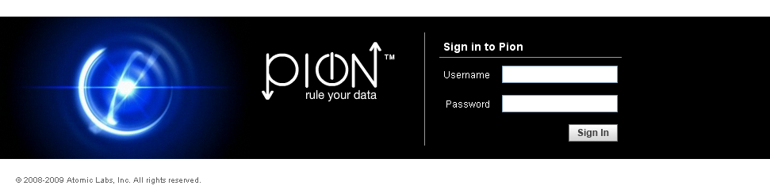
Enter your user name and password. The default username and password are both “pion” and it is strongly suggested that you change the default login information if you are the administrator. For more details on administration please see the chapter on managing users later in this guide.
After logging into Pion you will be presented with the Reactors Configuration screen where you will spend most of your time.
The screen is made up of four main sections (indicated in red):
- Along the left hand side of the screen you will find the Reactor Types toolbar. This toolbar contains the basic building blocks of every workflow you will design.
- The configuration workspace where you will draw your chain reactions.
- Workspace tabs are used to separated workspaces, making organization quick and easy.
- Navigation tabs for the different sections of Pion.

Reactor Configuration Page
The Pion Reactor Configuration page is where you build your chains. By dragging Reactors of different types to the workspace, and then connecting them, you define the sequence of data capture, processing, and output.

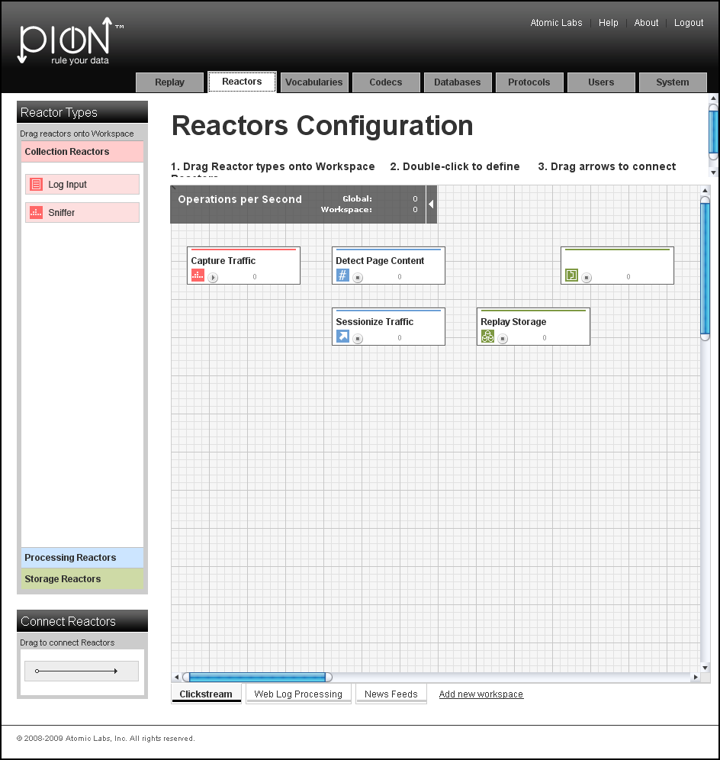

Reactor Types Toolbar
In the Pion application, the “Reactor Types” menu is divided along Reactor family lines. Working with reactors is pretty easy, because reactors can be dragged from the pallet on the left into the workspace area.
When you place the reactor in the workspace, you will be prompted for some basic naming information for the reactor plus any special information for the particular reactor you are creating. For example when you a Sniffer Reactor you are prompted for the general fields for “Name” and ”Comment” as well as two fields specific to the Sniffer Reactor.

29BCollection Reactors
Collection Reactors are responsible for getting data into Pion and therefore every Pion workflow needs to start with at least one collection reactor. Collection Reactors acquire the data from its native format and translate it into normalized Pion events that can be understood and processed by any other reactor.
The two main Collection Reactors are:
- Sniffer Reactor, which captures/monitors network traffic.
- Log File Input Reactor, which reads log files.

30BProcessing Reactors
After Pion has collected data it must do something with it in order to make it more useful. The Processing Reactors are responsible for manipulating and enriching the raw data to create the desired information.
The Processing Reactors include:
- Transform Reactor, which is able to do deep manipulation of the data in the data stream. For example, this can be as simple as formatting a URL to be something more easily readable or consistent if sites are constantly changing, or calculating dollar values from a page to see total spend (even taking into account if the currency must be converted). Because the Transform Reactor is very flexible, it can also do more complex things such as capturing and translating a bank branch or user identification on the fly.
- Session Filter Reactor, which enables you hold entire sessions until they meet certain criteria. The Session Filter Reactor must always be used after a Clickstream Reactor to ensure that the sessions are created. Using the Session Filter Reactor, you can do things such as saving full page view detail on only users that purchased a certain book or encountered an error.
- Aggregate Reactor, which is able to take large volumes of raw data and distill critical pieces of information out of them. For example, the Aggregate Reactor could count all of the web users on the site in the last hour, calculate the average page size the downloaded and tell you the total amount of traffic the site consumed in the last day. The Aggregate Reactor could even tell you each unique user name that accessed the site. Because it performs these calculations inside of Pion the Aggregate Reactor can do real-time report and reduce the stress on backend networks and systems which is especially critical in high volume applications.
- Fission Reactor, which splits input events into sequences of output events. For example, after receiving an input event of a news feed containing multiple RSS and XML items, the Fission Reactor can split the incoming event into an series of events containing only the RSS items.
- Content Hash Reactor, creates and then stores an md5 hash as an identifier (a content_id) for a specified content term in an HTTP response. This identifier is stored in a database, which is then used by the Replay feature when reviewing the user experience.
- SQL Reactor, which lets Pion interact with any relational database based on real time information. This means that Pion can gather additional information on sessions based on past activity. For example, you can see how much a customer spent during the last 2 years to add context to their session and to improve segmentation for analytics. Based on real-time information, the SQL Reactor can also update or insert data in the database to ensure that the information you have is always the most current possible.
- Filter Reactor, which filters information based on any number of criteria you might set. For example, you could do something simple like only looking at a particular set of users of web servers, or you could do something much more complicated such as only tracking certain individuals who are spending more than $50 on kitchen ware in their sessions.
- Clickstream Reactor, by understanding how browsers normally communicate with backend systems and how session state is maintained, is able take raw web traffic and organize it into logical pages and individual user sessions. The Clickstream Reactor does this in order to determine who is who and gather overall session statistics such as visit length, pages viewed, images viewed, time per page view, and more. Often, you won’t have to configure any of the options inside of the Clickstream Reactor for it to work correctly. If necessary though, though the Clickstream Reactor also contains the ability to handle very complex and custom sessionization parameters that are sometimes employed by very large applications to maintain session state across globally distributed application instances.
- Python Reactor, which allows you to use the Python programming language to collect, manipulate and store events within Pion.
- Script Reactor, which enables you to leverage existing command line scripts to quickly add capabilities to Pion. Using Script Reactor, you can do things such as create follow-up queues based on customer behavior or retrieve additional information from disparate sources on the fly.

31BStorage Reactors
Storage Reactors are needed whenever data needs to be persisted for later use for reporting or record keeping. For web analytics to take place a Pion workflow must always end with a Storage Reactor.
The main Storage Reactors include:
- Database Output Reactor, which enables Pion to store information in almost any database. The Database Output Reactor handles the format translation, table organization and performance tuning aspects required to ensure Pion events are written with the best performance and quality possible. To ensure high performance, native database communication is available for MySQL, Oracle, Microsoft, Sybase, IBM, Informix, Centura, Interbase, PostgreSQL and SQL Lite databases. The Database Output Reactor can also send data to any ODBC compliant database for storage. Because Pion enables direct database output, it can be easily integrated into any business intelligence implementation or data warehouse without requiring custom code or a separate extract, transfer and load (ETL) tool.
- Google Analytics Reactor, which is able to take web user behavior information and send it to Google Analytics servers via its native web services interface in real-time. From Google Analytics perspective, data collected by Pion is indistinguishable from that collected via page tags. All you need to supply is the correct Google Analytics Account ID and site name to connect Pion to Google Analytics.
- Omniture Genesis Reactor, which is able to take web user behavior information and send it through the Omniture Genesis integration system to SiteCatalyst via its native web services interface (in real-time) or the XML loading interface. All you need to supply is the relevant account information and site name to connect Pion to Omniture..
- Log Output Reactor, which enables you to write any data to a structured flat file of your choice in real time. This is often very useful for web analytics, because most tools are written to take in web server files as their default input format. Pion can capture, process and enrich user information before creating the distilled log files for use by other tools. This enables Pion to easily integrate with almost any on-site web analytics package including the open source efforts.
- Multi Database Reactor enables Pion to store data in several databases, based on the data being stored.
Once Reactors have been dragged into the workspace and connected, you can:
- Double-click on a Reactor to display its configuration dialog. You can then change the Reactor's configuration or connection characteristics.
- Right-click on a Reactor to:
- Display the Reactor's configuration dialog. You can then change the Reactor's configuration or connection characteristics.
- Display its configuration in XML format in a new page (note that this is read-only).
- Delete the Reactor.

The Vocabulary Configuration Page
This page allows you to manage and specify (define) the vocabularies used to describe events. Vocabularies allow you to define the terms and the format of the elements (data structures) that make up an event. There are six (6) built-in vocabularies:
- Clickstream
- RSS Channels
- Atom Feeds
- Stock Prices
- Aggregate
- Messaging (for SMTP)
If necessary, you can alter the built-in vocabularies, or even create your own specialized vocabulary to describe another kind of event.

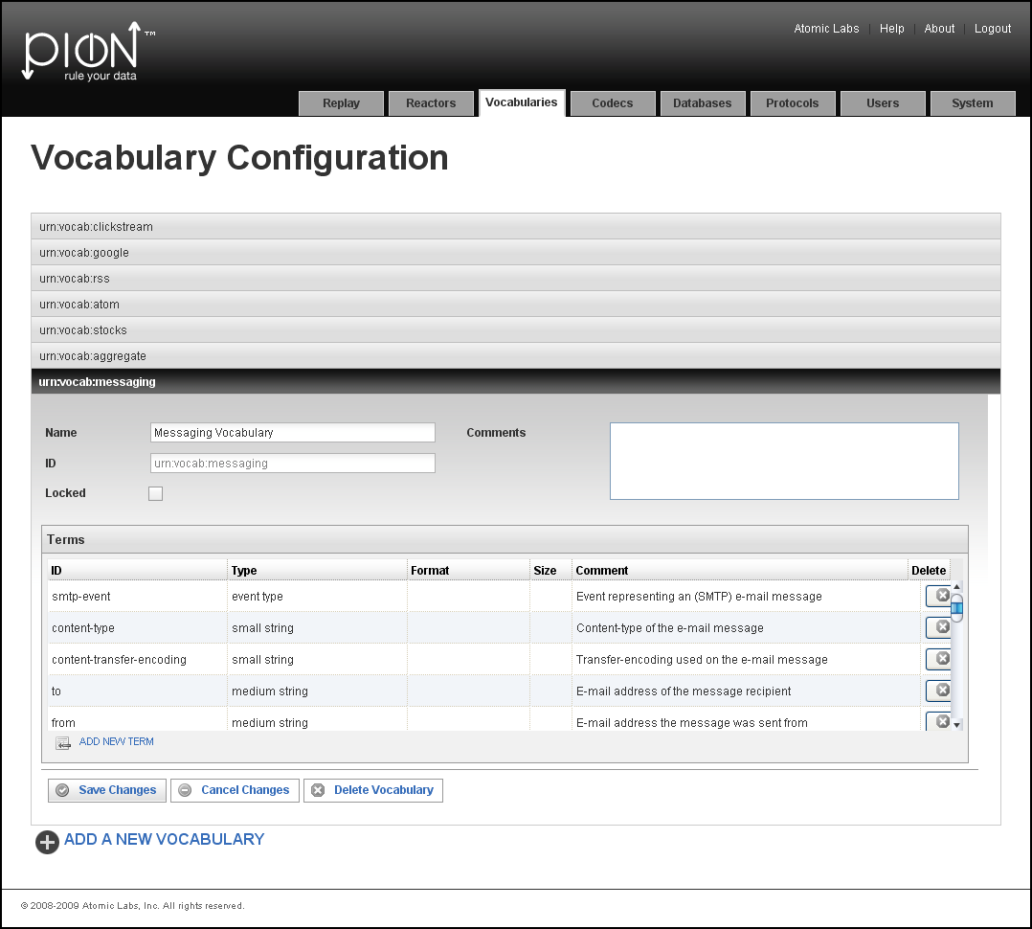

The Codec Configuration Page
A Pion Codec defines an input or output format for a log or a data stream (feed). Once the codec is defined, the log or data stream can be read and events can be created from the data in those logs/data streams. Codecs can also be used by Storage Reactors when writing events or results.
There are 18 built-in codecs in Pion:
- Common Log Format
- Combined Log Format
- Extended Log Format
- Page View Log Format
- Visitor Session Log Format
- WebTrends Log
- Response Content Log
- RSS Channel Extraction Codec
- RSS Channel Log Format
- RSS Item Extraction Codec
- RSS Item Log Format
- Atom Feed Extraction Codec
- Atom Feed Log Codec
- Atom Entry Extraction Codec
- Atom Entry Log Codec
- Stock Price Log
- JSON Log Format
- XML Log Format
If necessary, you can alter the built-in codecs, or create your own specialized codec to describe another kind of input or output format.

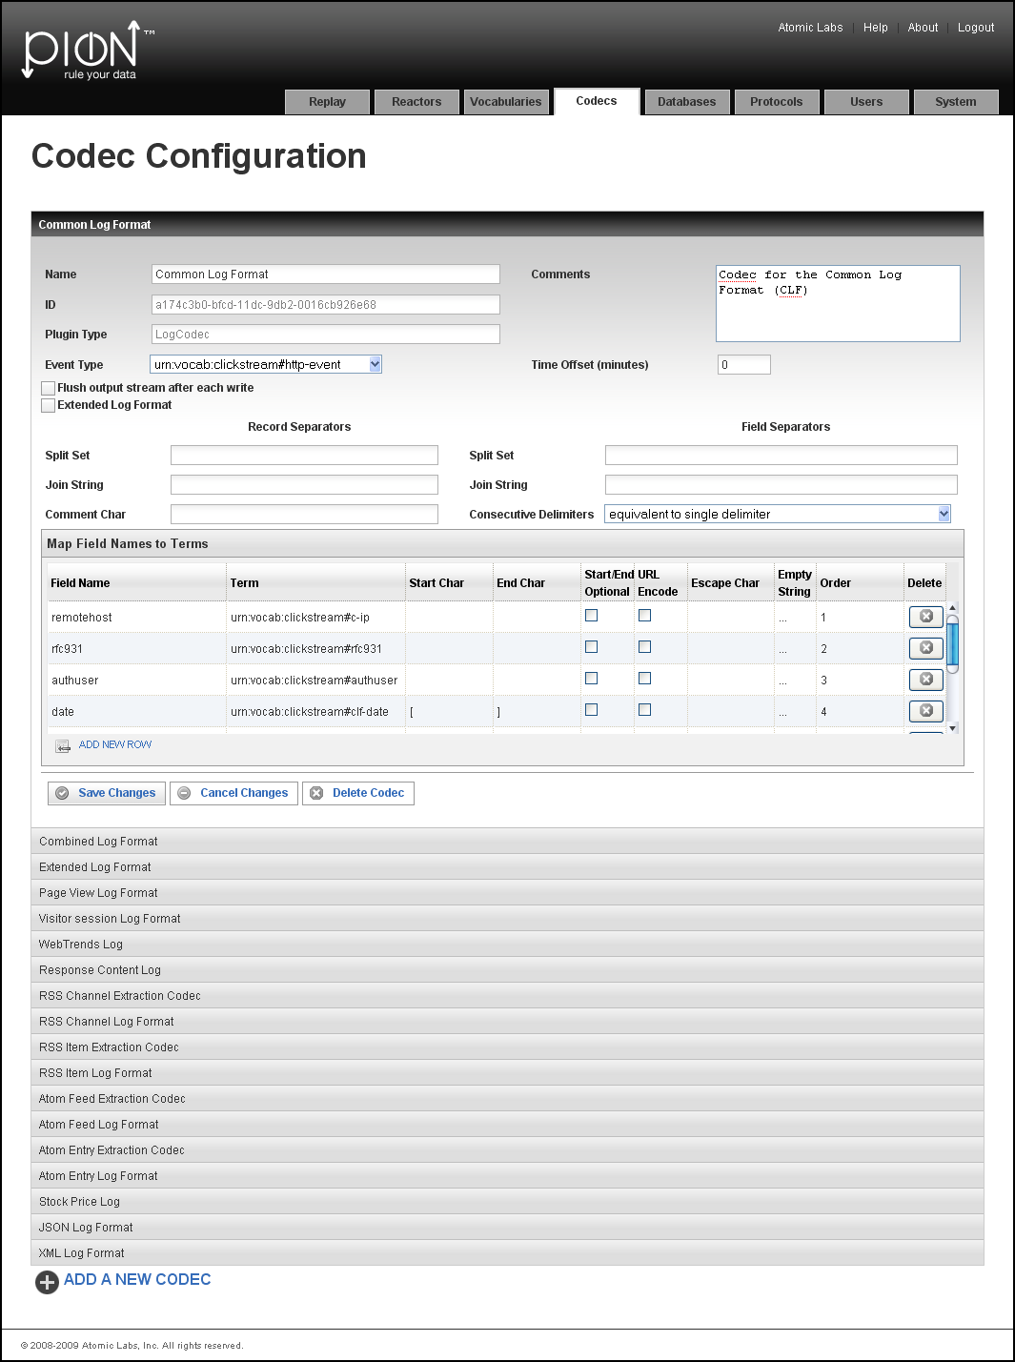

The Database Configuration Page
The Database Configuration Page is used to configure a connection with a database. Connecting to a database means:
Identifying the type of database (for example MySQL, SQLite or Oracle).
Note: In some cases, you will also have to identify the sub-type (engine) of the database being used. For example MySQL-MyISAM or MySQL-InnoDB; there are differences in the engines, and Pion makes effective use of those differences to optimize performance by changing the SQL syntax and/or the Isolation level.
Specifying the database connection information:
- The Username/Password for the Pion user account (the Pion login) on the database.
- The host/machine/instance of the database to connect to (host:port, or similar).
- The individual database instance (the database name space).
- The "connect strings" Pion uses to connect to the database (note that the connect string will be different for each kind/type of database, and may be different for individual databases of the same type/kind). For more information about connect strings, see http://sqlapi.com/OnLineDoc/Connection_Connect.htmlU
SQLite is Pion's embedded database, meaning it is always available, and by default will be used by Reactors, the analytics interfaces (for both Omniture Genesis and Google Analytics), and the Replay feature.
Note: SQLite is not a client/server database, though it is a RDBMS (relational database management system). Instead of a username and password pair, SQLite only has a file name.

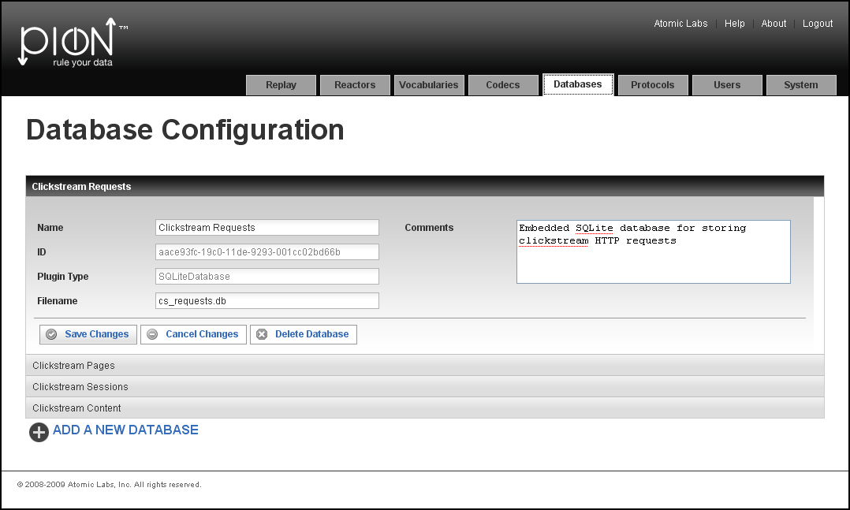

The Protocol Configuration Page
The Protocol Configuration Page is used to specify and configure the protocols Pion monitors. Currently there are two (2) basic protocols (HTTP and SMTP), and two (2) variations of the HTML protocol built-in to Pion:
- HTTP (No Content), which is used when Pion is monitoring visitor sessions to your web site(s), but not collecting data to be used by the Replay feature.
- HTTP (Full Content), which is used to capture the data required by the Replay feature. See “Using the Replay FeatureX“ on page X29X for more information.
- SMTP (Email) protocol, which is used to capture data by parsing/sniffing email traffic.
Because of Pion's extensible architecture, adding support for additional protocols is simply a matter of altering or creating codecs and/or vocabularies.

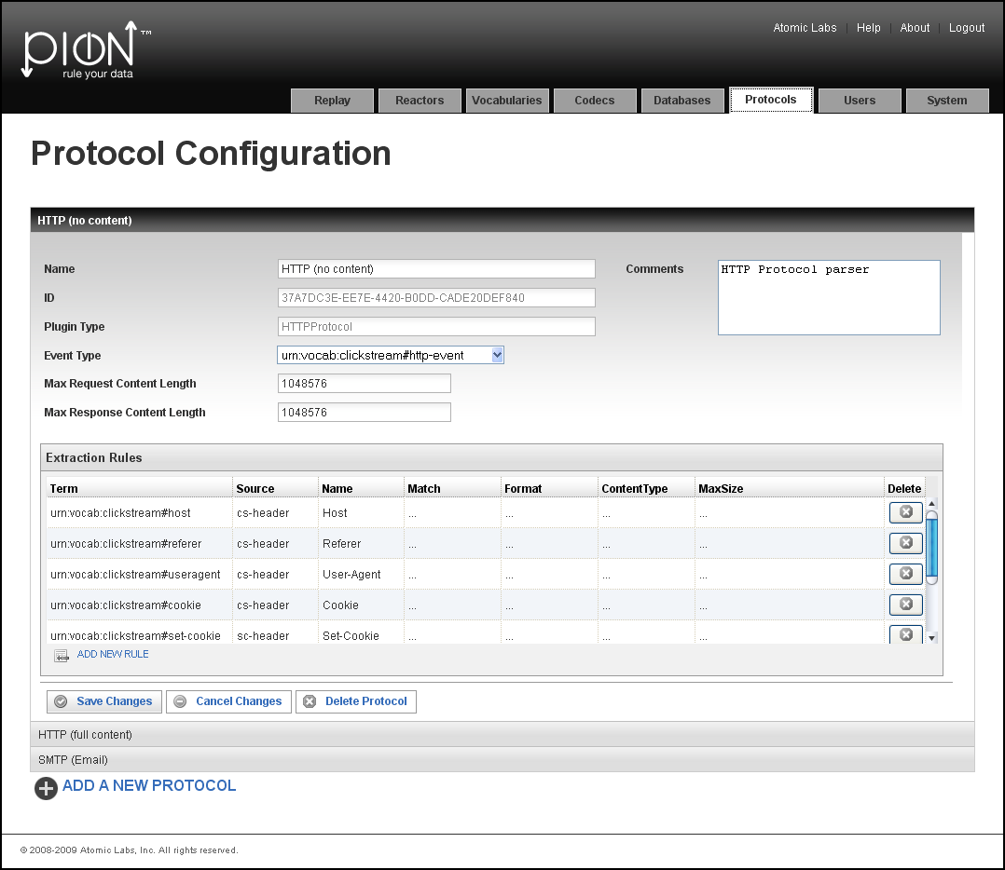

Managing and Configuring Pion

User Configuration
The User Configuration page is used to manage Pion user accounts. You can add, delete, or modify user accounts.

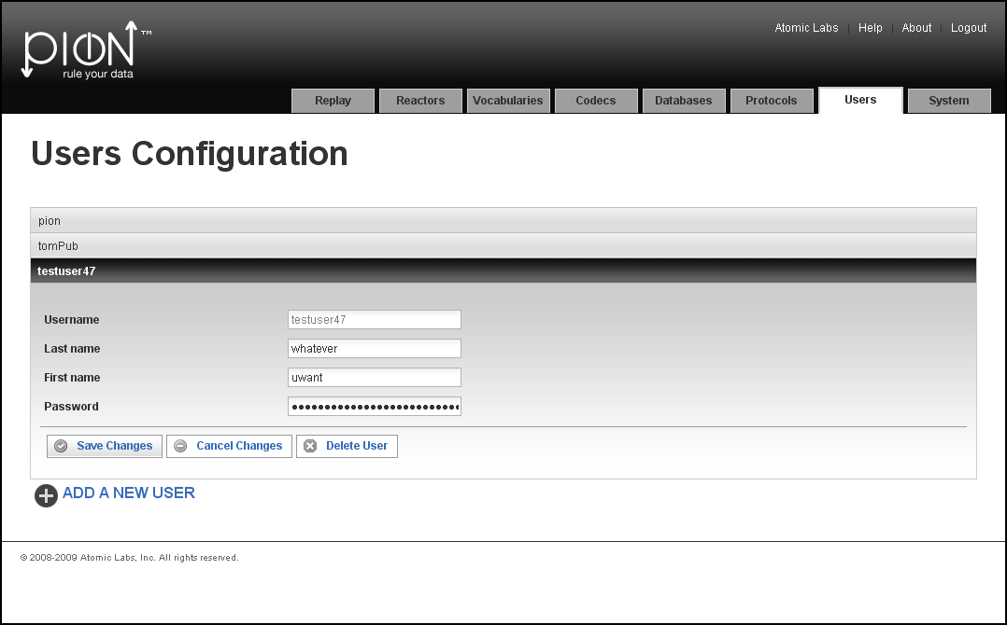

System Configuration
The System Configuration page is used to view the configuration of the Pion application, including configuration file location, services, configuration paths, and plugin paths. You cannot make changes from this page, but you can find out where the configuration files are, and then edit them separately, if necessary. Note that all configuration files are in XML format.
The System Configuration page is also where you can add a Reactor, Connection, codec, or database by importing the XML definition of the Reactor, Connection, codec, or database.

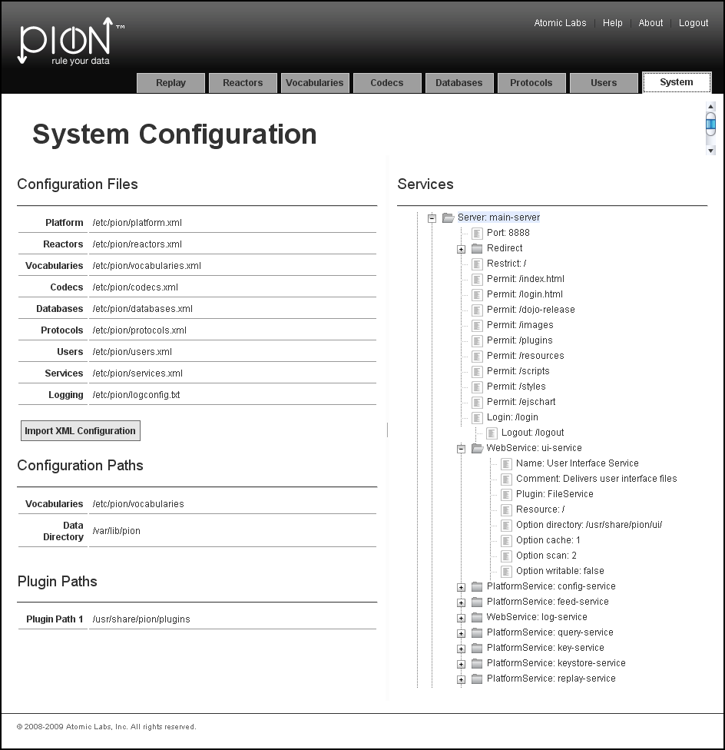

Using the Replay Feature
The Replay feature allows you to see what a visitor to your web site saw and “step through” their experience on your web site. The Replay feature captures the page views seen by a user, and allows you to see the pages the y saw, as the user saw them! Using Replay, you can also display information about the user's session, such as the client IP address, date and time, number of pages viewed, and more. The Replay feature:
- Uses the Content Storage Reactor and a database to store the content (pages).
- User can search sessions from "Sessions," "Pages," or "Requests" using configurable queries.
- Session contains multiple page views, which can be viewed in a browser ("you're seeing what the end-user saw").
To use Replay, Pion must be configured to monitor the web server, and the Content Storage Reactor and the Database Output Reactors must be properly configured.
Note: Currently, the only supported database for Replay is the embedded SQLite database. In future releases, additional databases may be supported.
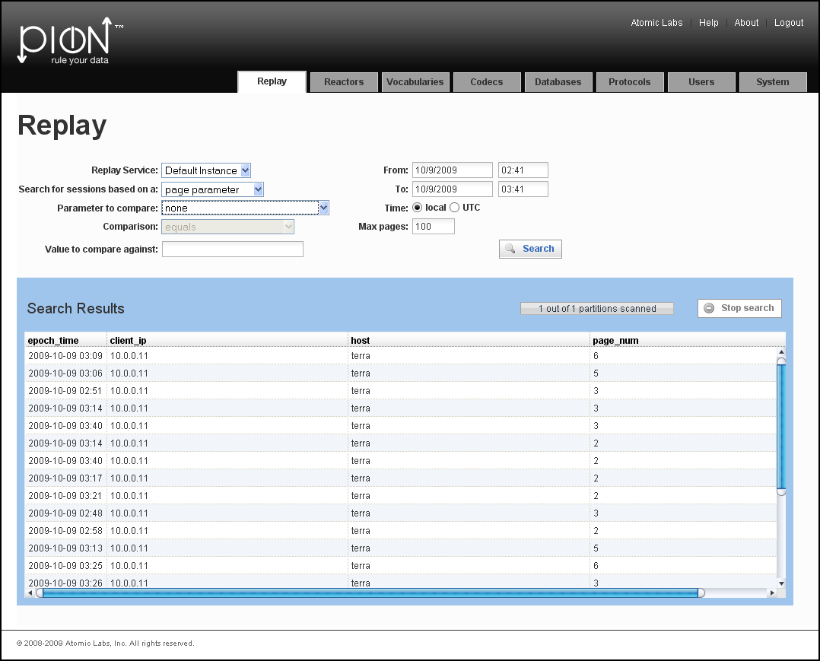
To replay a visitor's session:
- Go to the Replay page of the Pion application.
- Select the Replay Service (the Pion instance that is monitoring the web server that hosted the sessions you want to review).
- Using the drop-down list boxes, specify the search criteria for the session(s) you want to review:
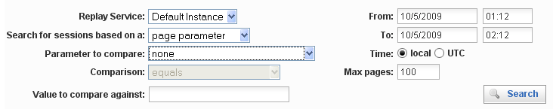
- Select the Search for session based on criteria. You can select one of the following:
- Session parameters, which include session-based information, such as server IP address, client IP address, user agent (the visitor's browser), referrer, cookie ID, and other factors relating to the session itself.
Because Pion 'sessionizes' web visits and stores that information in a database, using the Session parameters will be the fastest way to find particular sessions. Finding a particular session using Session parameters is more efficient than the other search criteria parameters because the database storing session information is smaller and will therefore be processed faster than the others. However, because there is a built-in delay to allow sessions to time-out (1800 seconds by default), you may want to use page or request parameters to locate the session.
There are two reasons to use the page or request parameters:
  - To see sessions that have not yet timed out (a way to handle the sessionizing timeout).
  - To be able to search based on parameters that are only available in page or request metadata. For example: status (to find sessions that had page-not-found requests) or page_title (to find sessions that hit a particular page title).
- Page parameters, which include page-based data, such as server IP address, host, page number, page status, URI query (the name of the called resource), and other parameters related to the page the visitor(s) viewed.
Finding a session using page parameters involves grouping all page views together into a Session view, which slows searches.
- Request parameters, which include details about the incoming client request, such as date, time, session ID, client IP, and other client-related details.
Finding a session using request parameters involves searching through all the individual requests, grouping all requests together, and other processing steps, making this the slowest/most resource intensive search type.
- Select the Parameter to compare criteria.
Depending on the selection you made in the Search for session based on criteria, the list of possible parameters to compare against changes. Select the parameter that will identify the user session(s) in which you have an interest. (You can select only one parameter at a time.)
Note: In the Parameter to compare field, selecting "none" (which is the default) provides a simple list/view of the events (with very little effort). Based on this list, you can then formulate your query more easily.
Select the Comparison to make:
- is-not-null, which means there must be a value (any type of value) to compare against. This will result in a list of requests/pages/sessions that have a non-empty parameter of the type you specified in the Parameter to compare criteria.
- is-null, which means there must not be a value to compare against. This will result in a list of requests/pages/sessions that have no value specified for the parameter of the type you specified in the Parameter to compare criteria.
- exact-match, which means an exact match to the string you will specify in the next step. This will result in a list of requests/pages/sessions whose Parameter to compare values exactly match the string you will specify in the next step.
- not-exact-match, which means “anything except an exact match” to the string you will specify in the next step. This will result in a list of requests/pages/sessions whose Parameter to compare values are anything other than the string you will specify in the next step.
- like, which means you will specify a character string, which will provide the pattern to compare against. Note that wildcards, such as "%" (a multi-character wild-card) and "_" (a single-character wildcard). This will result in a list of requests/pages/sessions whose Parameter to compare values match the pattern you will specify in the next step.
- not-like, which means you will specify a character string, which will provide the pattern to compare against. Note that wildcards, such as "%" (a multi-character wild-card) and "_" (a single-character wildcard). This will result in a list of requests/pages/sessions whose Parameter to compare values do not match the pattern you will specify in the next step.
- ordered-before, which means you will specify a string containing some form of sequence identifier, which will be compared against (a date, a numerical or alphabetic value). This will result in a list of requests/pages/sessions whose Parameter to compare values come before (are lower or earlier) in the sequence than the string you will specify in the next step.
- not-ordered-before, which means you will specify a string containing some form of sequence identifier, which will be compared against (a date, a numerical or alphabetic value). This will result in a list of requests/pages/sessions whose Parameter to compare values come after (are higher or later) in the sequence than the string you will specify in the next step.
- ordered-after, which means you will specify a string containing some form of sequence identifier, which will be compared against (a date, a numerical or alphabetic value). This will result in a list of requests/pages/sessions whose Parameter to compare values come after (are higher or later) in the sequence than the string you will specify in the next step.
- not-ordered-after, which means you will specify a string containing some form of sequence identifier, which will be compared against (a date, a numerical or alphabetic value). This will result in a list of requests/pages/sessions whose Parameter to compare values come before (are lower or earlier) in the sequence than the string you will specify in the next step.
- starts-with, which means you will specify a string, which will be compared against the beginning of the stored data. This will result in a list of requests/pages/sessions whose Parameter to compare values start with the string you will specify in the next step. Note that this comparison is not case sensitive.
- ends-with, which means you will specify a string, which will be compared against the final characters of the values in the stored data. This will result in a list of requests/pages/sessions whose Parameter to compare values end with the string you will specify in the next step. Note that this comparison is not case sensitive.
- contains, which means you will specify a string, which will be compared against the values in the stored data. This will result in a list of requests/pages/sessions whose Parameter to compare values include (contain) the string you will specify in the next step. Note that this comparison is not case sensitive.
Note: Comparisons depend on the specific database engine used to store the meta-data. Currently, Pion supports only the embedded SQLite database engine.
- Using the Value to compare against field, specify the search criteria for the session(s) you want to review.
Note: The Value to compare against field is disabled for comparisons for which it is not applicable, such as is-null and is-not-null.
Depending on the selection you made in the search criteria above, enter the value/regular expression/sequence identifier for comparison.
- Select the Date and time range for the period of the time in which you want to compare criteria.
Use the date and time controls to specify the start and end of the period you want to examine. For time values, select the radio button that indicates if the time you entered was the local time (the Pion instance's local time) or the UTC time.
- Optionally, you can specify the maximum number of pages to be returned by a search. If the number of pages within a session exceeds the number you specify, the additional pages will be truncated when viewed.
Use the date and time controls to specify the start and end of the period you want to examine.
- Click Search.
Note: If the search time exceeds 10 seconds, the search will time out. If you experience this situation, consider adding indexes. For information on optimizing searches and using Replay, see High-Volume Pion Implementation Guidelines, on page 15.
The search results, if any, are displayed below the search criteria area.
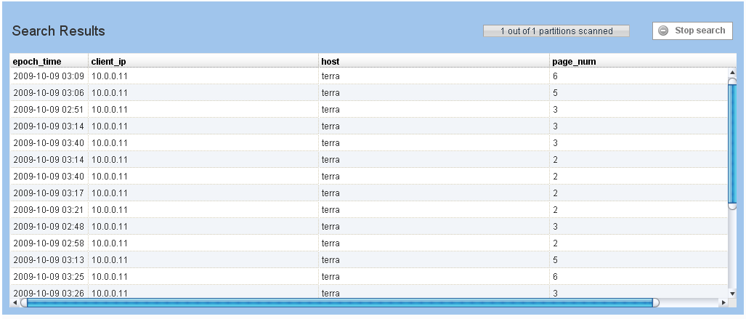
- Double-click on the session you want to view. The Replay window appears:
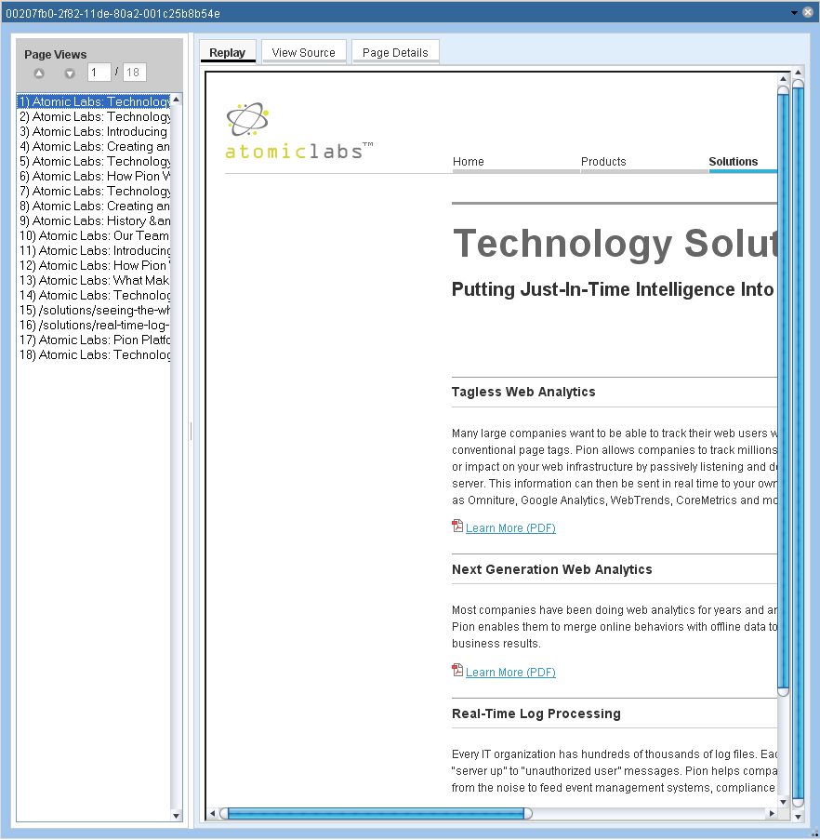
- To see the pages that the web site visitor saw, go to the Page Views list and click on the page you want to view.
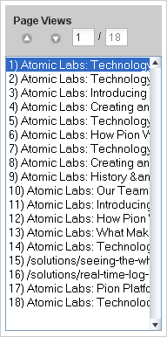
- To see the page source, select the View Source tab.
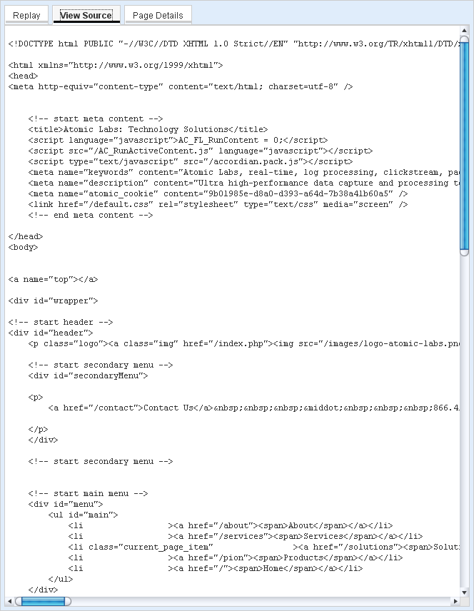
- To see the page details for the currently selected page view, select the Page Details tab.

Pion Reactors
This following sections of this document contain notes and other useful information about Pion reactors.
Reactor Type | Reactor Name | See Page
Collection | Log File Input Reactor | X38
Collection | Sniffer Reactor | X41
Processing/Transform | Aggregate Reactor | X46
Processing/Transform | Clickstream Reactor | X55
Processing/Transform | Content Hash Reactor | X63
Processing/Transform | Filter Reactor | X65
Processing/Transform | Fission Reactor | X68
Processing/Transform | Python Reactor | 71
Processing/Transform | Script Reactor | X75
Processing/Transform | Session Filter Reactor | X75
Processing/Transform | SQL Reactor | X77
Processing/Transform | Transform Reactor | X84
Storage | Database Output Reactor | X90
Storage | Google Analytics Reactor | X95
Storage | Log Output Reactor | X97
Storage | Multi Database Reactor | X99
Storage | Omniture Analytics Reactor | X102

Important Notes About Reactors
This section contains important information common to Pion and/or reactors, including naming conventions and other usage-related conventions, limits, and practices.

Database, Table, and Column Naming Conventions
Naming rules in Pion are a bit more restrictive than some databases, for example SQLite or Oracle. This is because Pion tries to support all databases. Because Pion’s naming rules result n names that are the ‘lowest common denominator,’ any name that is valid in Pion they should work in any database.
In Pion, database, table, and column names must conform to SQL92 compliant database rules, meaning that these names must:
- Start with a letter (a-z or A-Z)
- Contain only letters (a-z or A-Z), numbers (0-9) and the underscore character (_)
- Contain less than 32 characters
Note: While Pion Term names may contain dashes (-), periods(.), or the pound/hash sign (#) those characters are not allowed in database column names.

Comparisons
Comparisons are used in the following reactors: Aggregate Reactor, Clickstream Reactor, Database Output Reactor, Filter Reactor, Fission Reactor, Session Filter Reactor, and SQL Reactor.
Comparisons are used as filters, and a series of comparisons is called a filtering rule chain. The following applies to everywhere a series of comparisons is used. Ultimately, the goal of comparisons is to take an event coming into the reactor and get a Boolean (TRUE or FALSE) result.
What the result of any given comparison means is different for each reactor and use case, but the configuration (and the code it uses on the back end) is common:
Each row in the table can be referred to as a "Comparison." The order of comparisons is significant because comparisons are processed sequentially.
Each Comparison has: Term, Comparison (type), Value, and matching criteria (Match All and Match All Comparisons).
- Term, defines the value of the term to be used for the comparison logic.
- Comparison (type), specifies the type of comparison to perform (greater than, less than, matches, regular expression, etc.).
Note that the selections available for comparison change depending on the data type of the selected term. If you select a string for example, you cannot choose "less than" and if you select an integer, you cannot execute a regular expression match.
- Value, specifies a value to be compared against the value of the selected term.
For example, if you want only events whose term value is greater than 10 (numeric term type), you would select the Term (in the first column), the value "greater than" (in the second column), and a value of "10" (in the third column).
Matching criteria specify which of the defined comparison conditions must actually match in order to pass the filter.
- Match All, when filled, and if the term has multiple values (a very rare occurrence), then all values of the term must match for the Comparison to match. If empty (not filled), then only one value of the term must match for the Comparison to match.
- Match All Comparisons (check box), when filled, all Comparisons much match for the result of the rule chain to be TRUE. If empty (not filled), then any Comparison must match for the result to be TRUE. In all cases, if no Comparisons match (and at least one Comparison has been defined), then the result will be FALSE.

Reactor Input and Output Connections
Using Pion’s graphical interface (the workspace), you can easily connect reactors using the "Connect Reactors" tool.
To delete a connection, you can either:
- Move your mouse over a connection between two reactors on the Reactors workspace. The connection will be highlighted in yellow. If you then left-click on the connector, a dialog appears, asking if you want to delete the connection.
- Access the reactor’s configuration dialog (double-click on the reactor), and delete the connection from the reactor’s "Connections" section. When two reactors are connected, the connection can be deleted from either end of the connection.
Every reactor has a Connections section which describes the connections to and from the reactor. Depending on the reactor:
- Input connections describe the connection by which streams of events flow into this reactor (how events are captured).
- Output connections describe the connection by which streams of events flow from this reactor after being captured or processed.
There may be zero or more (any number) of each of type of connection. In the case of a Filter Reactor for example, events flow into the reactor from Input Connections. After processing, events that have met the Comparison rules are delivered to the other reactors, as described in the Output Connections, while events that do not meet the rules are dropped.
Typically, collection reactors do not have input connections, unless they are feeds, and storage reactors do not typically have output connections, unless they are feeds to other reactors which allow events to simply “pass through” the reactor.
Field | Description
From | The name of the reactor from which this reactor gets data (events).
Connection ID | The identifier of the connection between this reactor and the reactor receiving the data.
To | The name of the reactor to which this reactor passes data (events).
Connection ID | The identifier of the connection between this reactor and the reactor which receives the data.
To delete a connection, click on the “x” at the end of the row describing that connection.

Collection Reactors
Collection reactors are responsible for getting data into Pion and therefore every Pion workflow must start with at least one collection reactor. Collection reactors acquire the data from its native format and translate it into normalized Pion events that can be understood and processed by any other reactor.
The two main Collection reactors are:
Log Input Reactor, which reads log files.
Sniffer Reactor, which captures/monitors network traffic.
These reactors are described in the following sections.

Log File Input Reactor
The Log File Input Reactor can capture data from any structured text file so long as that file’s format is defined in a “Codec.” A Pion Codec defines an input or output format for things like logs. A Codec can also define notation such as JSON or XML. Codecs are used to 'break' data into chunks that can be recognized or manipulated.
Pion understands all of the normal log formats associated with web server logs such as Extended Log Format, Combined Log Format, and Common Log Format out of the box as well as numerous other log formats. If Pion doesn’t already contain a Codec for the log format you need, you can easily create a new Codec that describes the log format.
Sometimes, log files are stored in compressed format. If Pion is trying to read a log file, and the name of the log file ends in one of the following file extensions, Pion recognizes that the file is compressed, and will decompress the file as a part of the read process.
.gz (gzip or GNU zip)
.bz2 (bzip2)
When you first add a the Log File Reactor you will be prompted for the following fields:
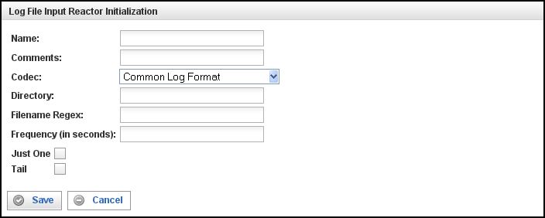
Field | Description
Name | Specify the name of this Log File Input Reactor. This can be any name you find descriptive, we recommend something which describes the log file(s) being read.
Comments | Enter some descriptive comments about this Log File Input Reactor. Any comment you feel will help you in the future, we recommend choosing something about the content or source of the log file(s), or the way in which the data in the files has been gathered or manipulated prior to being read.
Codec | Select the Codec to be used when reading the log file contents from this drop-down list. By default, the Log File Input reactor supports the following Codecs:  - Common Log Format  - Combined Log Format  - Extended Log Format  - Page View Log Format  - Visitor Session Log Format  - WebTrends Log  - Response Content Log  - RSS Channel Extraction Codec  - RSS Channel Log Format  - RSS Item Extraction Codec  - RSS Item Log Format  - Atom Feed  - Atom Feed  - Atom Entry  - Atom Entry  - Stock Price Log  - JSON Log Format  - XML Log Format
Directory | Specify the complete path to the directory containing the log file(s) to be read.
Filename Regex | Enter a regular expression or a file name to be used to determine the log file(s) to be read.  Note: A file name will be interpreted as a regular expression. If the file name contains a period, the period should be escaped.
Frequency | Define the amount of time (in seconds) for the interval between checking for new log files whose names match the Filename Regex.
Just One | Fill this check box to read only the first record of a log file, converts it to an event, and repeatedly duplicate and output that event until the reactor is stopped. (This is useful for testing.)
Tail | When this check box is filled, after reaching the end of a file, Pion keeps it open and periodically checks for newly appended data. (Based on the Unix 'tail -f' command.)

This creates the Log File Input Reactor in the workspace. Double-clicking on the reactor brings you to the configuration screen:
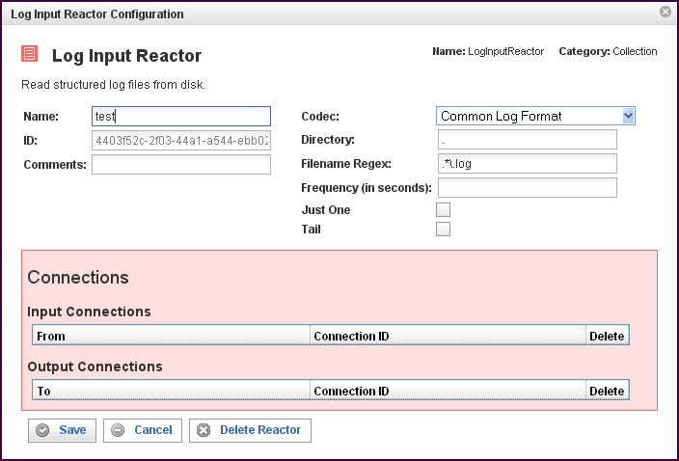

In addition to the fields you saw when adding the reactor initially (described above), you will see one additional field and the Connections section. The additional field is:
Field | Description
ID | The reactor ID, a unique ID generated by the Pion server. This ID identifies a particular reactor.

The Connections Section
The Connections section describes input and output connections for this Log Input Reactor. See “Reactor Input and Output Connections“X on page X37X for more information.

Sniffer Reactor
The Sniffer Reactor captures and decodes traffic from network interfaces. This can be live traffic traveling through a network in real time or previously captured traffic stored in a standard PCAP format. The Sniffer Reactor understands any network protocol for which you have installed a Pion plug-in (for example plug-ins are available for the HTTP, HTTPS, and SMTP protocols). With the proper plug in, Pion can see and understand traffic on the network, such as traffic between web servers and clients, and can generate events based on that traffic.
When you first add a the Sniffer Reactor you will be prompted for the following fields:
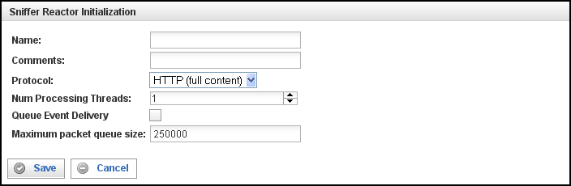

Field | Description
Name | Specify the name of this Sniffer Reactor. This can be any name you find descriptive, we recommend something which describes the network segment to which this Sniffer Reactor is listening.
Comments | Enter some descriptive comments about this Sniffer Reactor. Any comment you feel will help you in the future, we recommend choosing something that includes the contact person for the network segment and any associated work code that may be needed in the future.
Protocol | From this drop down list, select the protocol you want the Sniffer Reactor to use when listening to traffic. By default Pion supports the following protocols:  - HTTP (no content) captures the critical fields needed by web analytics tools. These fields include those pertaining to URL, host, referrer, page title, user agent, cookie and query.  - HTTP (full content) captures the critical fields needed by web analytics tools, and also captures the page content and the full client request.  Page content (from the request and the response) is saved into a special field in the clickstream term called sc-content. The maximum amount of data in sc-content can be defined in the Protocol configuration. The default is 512k for sc-content.  The client request is saved into a special field in the clickstream term called cs-content.  Note that capturing using the HTTP (full content) protocol requires more memory than capturing using the HTTP (no content) protocol. More memory is required because more data must be captured and manipulated, and because the amount of data making up page content is often much more than any other field.  - SMTP captures the critical fields from SMTP-based emails, allowing you to generate events based on emails. All standard SMTP header fields and the message body are captured.  The maximum amount of data stored from the message body can be defined in the Protocol configuration (the default is 1MB).  The default is HTTP(full content) because it contains all of the information, if you are limited in memory or don’t need page content then it can be easily switched to improve performance.
Num Processing Threads (Number of Processing Threads) | Specify the number of processing threads a Sniffer reactor uses. It is useful for provisioning resources on the Pion server or in a shared environment. Adding more available processing threads can improve the performance of Pion significantly on machines with multiple processing cores.  Note: Generally you should not use more threads than you have CPUs/Cores in the Pion server.
Queue Event Delivery | Fill this check box to cause events to be delivered to other reactors by threads not affiliated with this reactor (other threads in Pion). Enabling this feature distributes workload and adds an additional memory-based work queue, which may reduce overall performance.  If this check box is empty, the feature is disabled and the processing threads of this reactor also handle the delivery of events to other reactors. Disabling this feature may improve overall performance because there will be less context switching.
Maximum packet queue size | Specify the maximum number of packets that can be in the event queue per processing thread. We recommend that the total (this value * number of processing threads) be between 200,000 and 300,000.  Note that the queue size setting has a direct impact on possible memory consumption, and that it also determines how much you can buffer in a burst. You must set the queue size to balance between these considerations according to your needs and resources.
Once the Sniffer Reactor has been added to the workspace it must be configured to listen to network traffic. By double clicking on the reactor you will open the following configuration screen:
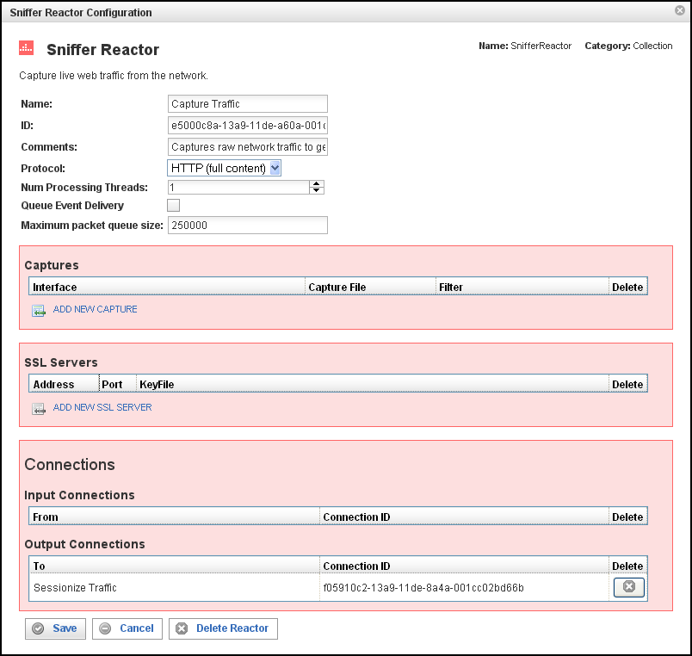

In addition to the fields you saw when adding the reactor initially you will see sections for Captures, SSL Servers and Connections.

The Captures Section
This section specifies where your Sniffer Reactor will be getting data from. Each line represents a data source and a filter to be applied to that data source. There are two types of supported data sources; Interfaces and Capture Files.
Field | Description
Interface | Specifies the network interface to use when listening to traffic.  Select the cell in the Interface column to display an automatically populated drop down list of the network interface cards on the Pion server. You can then choose the interface that is receiving the live traffic you want to listen to.  Interfaces include:  - eth0 / eth1 / ethX (Ethernet interfaces)  - wlan0 (or similar, wireless interfaces)  - lo / lo0 (or similar, often "loopback" devices)  Note: If you are running VMware, there will be many other virtual interfaces, between the VM and the host.  To see the devices, their IP addresses, and other interface information:  - On Windows operating systems, run the command "ipconfig /all".  - On Unix-based operating systems, run the command "ifconfig -a".
Capture File | Specifies a file that contains saved traffic. This content of the file will be used instead of live traffic from an interface.  If the traffic has already been captured in a file, simply type the full file path in the Capture File column (note: the file must be a standard .cap or .pcap file).
Filter | Defines the filters to apply to the traffic received on the interface specified above.  After selecting your traffic sources, you can filter out traffic which Pion doesn’t need to see. Although traffic can be filtered out later using other reactors, doing it at this stage as part of the Sniffer Reactor is the most efficient way to remove unwanted information. The filter reactor uses the same syntax as the tcpdump utility. For example if you only wanted normal HTTP traffic you would use “tcp port 80” as your filter string to remove all non HTTP traffic. Complete tcpdump syntax can be found at http://www.tcpdump.org/tcpdump_man.html.
Click on the ADD NEW CAPTURE icon to add a new line to the table.
To delete a capture, click on the “x” at the end of the row describing that capture.

The SSL Servers Section
This section is used only for sites that use SSL encrypted communications such as those common in retail, defense, and financial applications. Pion is able to decrypt data in real-time provided it has the proper keys.
To specify an SSL server, simply click the ADD NEW SSL SERVER icon and specify the following:
Field | Description
Address | The IP Address or DNS name of the SSL server.
Port | The value specified is used in conjunction with the Address (above) to determine if the traffic is encrypted using the provided keyfile (below).
Keyfile | The path to the SSL key file. This path must be relative to the Pion server to ensure proper access. The key can be any standard PEM formatted file.
To delete a server, click on the “x” at the end of the row describing that server.

The Connections Section
The Connections section describes input and output connections for this Sniffer Reactor. See Reactor Input and Output ConnectionsX on page X37X for more information.

Processing Reactors
After Pion has collected data it must do something with it in order to make it more useful. The Processing reactors are responsible for manipulating and enriching the raw data to create the desired information.
The Processing reactors include:
- Aggregate Reactor, which is able to take large volumes of raw data and distill critical pieces of information out of them.
- Clickstream Reactor, which is able take raw web traffic and organize it into logical pages and individual user sessions.
- Content Hash Reactor, which creates and then stores a hash identifier for a specified content term in an HTTP response. These identifiers are used by the Replay feature to eliminate duplicate responses and determine which ones to store into databases.
- Filter Reactor, which filters information based on any number of criteria you might set.
- Fission Reactor, which splits input events into sequences of output events.
- Script Reactor, which enables you to leverage existing command line scripts to quickly add capabilities to Pion.
- Session Filter Reactor, which enables you hold entire sessions until they meet certain criteria.
- SQL Reactor, which lets Pion interact with any relational database based on real time information.
- Transform Reactor, which is able to do deep manipulation of the data in the data stream.
These reactors are described in the following sections.

Aggregate Reactor
The Aggregate Reactor can distill critical pieces of information from large volumes of raw data. For example, the Aggregate Reactor could count all of the web users on the site in the last hour, calculate the average page size downloaded and tell you the total amount of traffic the site consumed in the last day. The Aggregate Reactor could even tell you each unique user name that accessed the site. Because it performs these calculations inside Pion, the Aggregate Reactor can do real-time reports, which reduces stress on your backend networks and systems, which are critical for high volume applications.
When you add an Aggregate Reactor you will be prompted for the following fields:
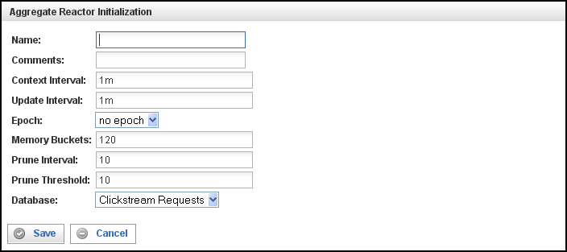

Field | Description
Name | Specify the name of this Aggregate Reactor. This can be any name you find descriptive, we recommend something which describes the data this Aggregate Reactor is gathering.  The name may contain any combination of letters and numbers.
Comments | Enter some descriptive comments about this Aggregate Reactor. Any comment you feel will help you in the future, we recommend choosing something that describes the data being gathered and/or the data being ignored.
Context Interval | Specifies how often the Memory Bucket (the context) is changed. Use a numeric value, followed by a time unit, as indicated by one of the following letters:  - S for Seconds (the default)  - M for Minute  - H for Hour  - D for Day  - W for Week  - Y for Year (365 days)  Once Context changes:  An event of type aggregate#stat-event is sent with all values.  For Unique, an event for *each* unique string is sent.  A database row is added (if a database is enabled).  A new "tick" will be present in graphs & queryService XML (for information on using the Query Service, see “Using the Query Service with the Aggregate ReactorX” on page X53X).
Update Interval | Indicates how often updates to the current Memory Bucket (update events, #update-event) are sent out.  The Update Interval must be smaller than the Context Interval and is usable only if your Context Interval is very large, and you are processing update events. For the time unit notation used to specify the duration of the Update Interval, see “Context Interval” (above).
Epoch | Defines the unit of the starting point for the Memory Bucket. For example, an epoch of a “day” means that all buckets are based on the change of the day (when a new day begins, or hour “0”). If Epoch is not defined, first bucket starts at the program start-up time. Use the drop-down list to select the Epoch.
Memory Buckets | Specifies how many Context Intervals are kept in memory. This number can be quite large, 1MB of memory can hold ~ 20,000 - 30,000 buckets.  Commonly referred as a “Bucket” or “Bin,” a Memory Bucket is a time-bound container for elements. The length of time the Memory Bucket covers (spans) is determined by the Context Interval. Total time interval is (Context Interval x Memory Buckets).  When counting events, a Memory Bucket of 1 minute is used to count all events that occur within a minute. Using 120 Memory Buckets that have a Context Interval of 1-minute (120 1-minute buckets), you can graph event frequency for a two hour span. To make fine-grain graphs, use a large Memory Bucket value, a short Context Interval, and use Grouping in the query.
Prune Interval | Specifies how often the unique values are pruned. The Prune Interval is expressed as a multiple of the Context Interval (for example 10 x 1m = 10m).
Prune Threshold | Specifies the minimum number of times a unique value must be found in order to be counted. If the minimum number is not met, instances of that value are purged and no longer tracked.  The Prune Threshold is intended to prune out (eliminate) values that are aberrations, and which would otherwise indefinitely consume an Aggregate Reactor, without providing meaningful amounts of data.  For example, assume you are looking for a particular value, say page title. If there is a page title where the value is "blue moon" and a prune threshold of 10, then if there are less than 10 counted instances of "blue moon" then this value gets dropped, and is no longer tracked (until another instance).
Database | If defined; identifies a database (that must be one of the supported database types SQLite, MySQL, Oracle, etc.) in which statistical events will be stored. The database name (specified in the reactor configuration) defines where tables will be created, and all the statistical events will be stored in this database table. Note that the database table name matches the name of the aggregate, so aggregate names are restricted by same rules as database table names.  For example, if you want to have Aggregate Reactor save its statistics on a continuous basis into a database table, then define a database, and it will happen.  If you do not define a database, you will still get:  Statistical events produced (you can use them for any normal processing, a log output reactor, or such).  The graphs (click on the graph button on aggregate).  The statistics in XML format. To see statistics in XML format, use SOAP style URI (see bottom of the graph dialog for the URI).  Feed output from Aggregate Reactor.

This creates the Aggregate Reactor in the Workspace. Double-clicking the reactor brings you to the Aggregate Reactor Configuration screen:
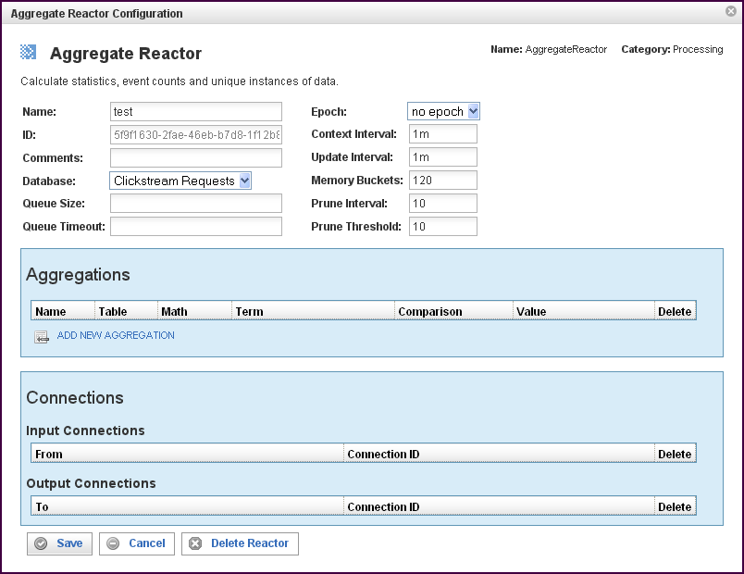

In addition to the fields you saw when adding the reactor initially (described above), you will see some additional fields and sections for Aggregations and Connections. The additional fields are:
Field | Description
ID | The reactor ID, a unique ID generated by the Pion server. This ID identifies a particular reactor.
Queue Size | The number of events allowed in the queue before triggering a flush of the queue. When the queue is flushed, the queued events are inserted (bulk-inserted) into the database specified in the Database field. The default queue size is 1000 events.
Queue Timeout | The queue timeout determines how long to wait before forcing a queue flush (a bulk-insert of queue contents to the database into the database specified in the Database field. The default queue timeout is 10s (10 seconds).

The Aggregations Section
The Aggregations section specifies the data that will be processed from the database selected above. Click on the ADD NEW AGGREGATION icon to add a new line to the table. Each line represents a data item to be processed and the processing operations for that data item.
Field | Description
Name | Identifies the aggregation. This can be any name you find descriptive, we recommend something which describes this aggregation.  The name may contain any combination of letters and numbers, and my contain underscores, but may not start with a number or an underscore.
Table | Specifies the name of the database table in which to store the Context records. The table name must be unique (within the specified database), and is not case sensitive. The name must be made up of any combination of letters and numbers.
Math | Specifies a mathematical operation to be applied to the value of the data item:  Count applies to any term, and it causes Pion to count the total number of values (unique or repeated).  If the term exists in an event, it is counted. Count returns a number n (the number of events containing the term) and a time (the amount of time in which the events occurred). Count may be used to graph how many events occurred in a specific time period. Count is a good way to count things like page hits, incidents, and frequency.  Sum applies only to numeric terms, for example clickstream#bytes, and it enables Pion to compute any or all of the following::  - SUM (add the values together).  - MIN (find the lowest value).  - MAX (find the highest value).  - AVG (calculate the average value).  - N (counts the number of values).  Sum can also compare the data values to a comparison term, such as greater-than and the value “0.”  Sum is good for presenting traffic, volume, max load, and changes in average.  Unique applies only to string terms/fields, for example clickstream#request, and it causes Pion to count the total number of unique (non-repeated) values:  - Any unique value creates a new counter (also known as a “slot" or an "accumulator").  - Once a counter is created, the number of unique values is counted.  - Upon a pruning interval, if the count is less than the pruning value, the accumulator is discarded. (See the description of prune threshold above.)  Unique is good for presenting things like a spread of status messages and the ratio of pages viewed. Unique is most useful when combined with a Regular Expression, for example "GET (.+)&" and, when Unique finds a new unique string, it starts a new unique count for that string.  Use Pruning to take out edge condition matches.
Term | Defines the value of the term to be used for the comparison logic. Specifies the data item to find. You can select a term (an identified data item) from an existing vocabulary, or you can add a new vocabulary and define the term(s) to be found.  One event consists of multiple Terms. For example, a stock event consists of terms "symbol" and "price." Note that one term may contain multiple values.
Comparison | Specifies the type of comparison to test, such as true/false or is-defined/is-not-defined. (Note, do not use TRUE/FALSE in an Aggregate Reactor).  Depending on the term that is specified in a row, an appropriate list of comparisons will appear in the comparison cell of that row. For example, if it's a date type, you'll get choices like "earlier than", whereas if it's a string type, you'll get choices like "starts with".  Like most comparisons, these two examples require a value to compare against, but a few comparisons, like “is defined,” do not require a value to compare against.  For more information on comparisons, see "ComparisonsX””“ on page 36X.
Value | Defines the data value to test against (or the regex to apply to the data values).

To delete a data item, click on the “x” in the delete column for the line describing that data item.

The Connections Section
The Connections section describes input and output connections for this Aggregate Reactor. See “Reactor Input and Output Connections“X on page X37X for more information.

Using the Query Service with the Aggregate Reactor
Aggregate Reactor can be queried using the Query Service (QueryService). To use the Query Service, construct the query and enter it as a URL In your browser. For example:
http://host:port/query/reactors/reactor-id/aggname?VEC=1/dt/x,1/n/y&GRP=grp
Where:
- host is the host name or IP of the Pion server.
- port is the port number of your Pion installation.
- reactor-id is the ID of this Aggregate Reactor. (To obtain the reactor ID, right click on the Aggregate Reactor and select “Show XML”.)
- aggname is the name of the aggregate.
- VEC=1/dt/x,1/n/y is the list of vectors.
- grp is the number of values to group into a single data point.
Query results are returned in the form of a graph.

57BUQuery Service Parameters
All Query Service parameters are optional. When specified, Query Service parameters are in the format PARAMETER=VALUE, and parameter/value combinations are separated by the ampersand character (&).
The Query Service parameters are as follows:
- VEC (list of vectors)
The list of vectors is separated by commas. Vectors are specified using the format:
aggname?VEC=1/dt/x,1/n/y
Where:
- aggregate is the name of the aggregate.
- VEC= indicates the beginning of the list of vectors.
- dt is the DateTime
- x indicates to place this vector on the X axis of the graph.
- y indicates to place this vector on the Y axis of the graph.
List as many vectors as necessary, separating vectors in the list with commas, for example:
aggname1/dt/x, aggname2/dt/x, aggname3/dt/x, aggname4/dt/x, aggname5/dt/x, aggname6/dt/x, aggname7/dt/x[,...]
- PTS (points to display)
Points to display indicates how many data points to display on the graph. Specified as PTS=n, where n is the number of points to display. The total time frame of the graph is calculate as follows:: ((PTS * Context Interval) / GRP).
If PTS is greater than (Memory Buckets / GRP), the graph will be truncated.
- GRP (grouping)
Grouping specifies how many samples are grouped.
- 1 = No grouping
- 2 = Groups two adjacent samples together
- 3 = Groups three adjacent samples together
For example, to group 10 minute samples into a data point covering one hour, use a value of 6.
- ENC (Encoding)
Controls the encoding to be used. Specified as ENC=enc, where enc is one of the following:
- XML (Full XML)
- XML-S (Shorthand notation XML)
- XML-C (Compressed XML)
Note: The data sets can be enormous, so if your application can read it, Pion recommends that you use compressed or shorthand XML.
- DAT (Date String format)
- 0 = Time expressed as milliseconds since 1970-01-01
- 1 = Time expressed as seconds since 1970-01-01
- 2 = Time and Date in format: "01 January 2008 17:25:01"
- 3 = Time and Date in ISO format "20080101T172501"
- RND (Random data)
Returns random data, for testing purposes.
- MVY (MultiVectorY)
- 0 = Split each vector to a separate data set in XML.
- 1 = Combined multiple Y vectors into one data set in XML.

Clickstream Reactor
The Clickstream Reactor is able take raw web traffic and organize it into logical pages and individual user sessions. It does this in order to identify users and overall session statistics such as visit length, pages viewed and more. The Clickstream reactor accomplishes this by understanding how browsers normally communicate with backend systems and how session state is maintained. Often the Clickstream Reactor works properly without changing any configuration options. The Clickstream reactor contains the ability to handle very complex and custom sessionization parameters, which may be employed by large applications to maintain state across globally distributed application instances.
The Clickstream Reactor functions as follows:
- Page detection is controlled by the page object detection.
- Requests are assigned to pages using timestamps and referrer headers -- the algorithm supports having several pages open at a time, up to the specified "maximum pages per session."
- Requests grouped within a page are ordered using timestamps (request-num).
- Pages are closed when either:
- No requests are associated with the page for a period longer than time specified by the "page timeout" parameter.
- The maximum number of pages per session is exceeded (oldest pages are closed first).
- All requests associated with a particular page will have the same session-id and page-num values in their http-event.
- When a page closes, a "page event" is generated that represents all the requests associated with a particular page.
Page events (type "urn:vocab:clickstream#page-event") contain the following clickstream vocabulary fields:
- date, time, date-time, epoch-time = timestamp for first http event associated with the page
- page-num = sequence number for the page view, starting with 1
- robot = 1 if the session is considered to be a "robot"
- bytes = total bytes for all requests and responses
- cp-rtt = the average round trip time in microseconds from the client to the Pion server
- cp-rtt-packets = the number of round trip time measurements from the client to the Pion server
- cp-rtt-sum = the sum of all round trip time measurements from the client to the Pion server
- cs-bytes = total bytes for all requests
- sc-bytes = total bytes for all responses
- page-title = title extracted from HTML content
- page-load = total time to load the page, from start of first request to end of last response
- page-load-redirect = total time for all redirected (302) page requests
- page-load-base = time-taken for the base HTML file
- page-hits = total number of HTTP requests associated with the page
- page-load-content = total time for all page object (not base HTML or redirected) requests
- page-dwell = total time from the last response to the first request for the next page view
- ps-rtt = the average round trip time in microseconds from the Pion server to the protocol server
- ps-rtt-packets = the number of round trip time measurements from the Pion server to the protocol server
- ps-rtt-sum = the sum of all round trip time measurements from the Pion server to the protocol server
- referer = copied from first http event associated with the page
- time-taken = the sum of microseconds that it took to complete all HTTP events associated with the page from the end user's perspective
The following fields are all copied from base HTML file request: session-id, session-group, uri-stem, uri-query, host, user-agent, client-ip, server-ip, status, uri, request, server-port, content-id, page-title, and content-type.
Page events may contain "sticky page fields" which are copied from http-events.
- Requests are assigned to sessions using the cookies configured in the Clickstream Reactor, and if no cookies are found, a combination of the user agent and the IP address are used for matching.
- When a session closes, a "session event" is generated that represents all the requests associated with a particular visitor session.
Session events (type "urn:vocab:clickstream#session-event") contain the following clickstream vocabulary fields:
- date, time, date-time, epoch-time = timestamp for first http event associated with the session
- session-id, session-group, date, time, date-time, referer
- session-pages = number of pages in the session
- session-requests = number of http requests in the session
- session-dwell = total dwell time for all page views
- session-length = total length of the session
- robot = 1 if the session is considered to be a "robot"
- bytes = total bytes for all requests and responses
- cs-bytes = total bytes for all requests
- sc-bytes = total bytes for all responses
- cookie-id = sessionizing cookies detected for the session
Session events may also contain "sticky fields." When found in a session event, the sticky field values are copied.
When you add a Clickstream Reactor you will be prompted for the following fields:
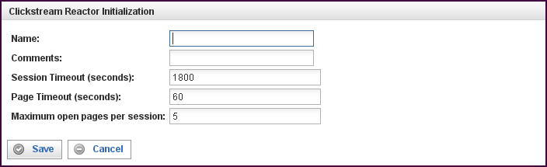

Field | Description
Name | Specify the name of this Clickstream Reactor. This can be any name you find descriptive, we recommend something which describes the session data this Clickstream Reactor is producing.  The name may be any combination of letters and numbers.
Comments | Enter some descriptive comments about this Clickstream Reactor. Any comment you feel will help you in the future, we recommend choosing something that describes the data being produced and/or the sessions being analyzed.
Session Timeout | Amount of time (in seconds) to wait before a session is considered to have timed-out. For example, if a user/browser is browsing a web site, the Clickstream Reactor will consider the user having abandoned/quit browsing the site after the specified number of seconds. The default timeout is 1800 seconds (30 minutes).
Page Timeout | Specifies the amount of time to wait (in seconds) before a page is considered to be closed. (Note that the time is measured from the last packet received, not the start time of the page.) When a page is closed, a page event is generated and delivered, along with all of its corresponding http request events, to the reactor's output connections. Any requests for objects within the page reset this timer.
Maximum open pages per session | The maximum number of concurrently open pages in any single user/browser session that the Clickstream Reactor will analyze.

This creates the Clickstream Reactor in the workspace. Double-clicking on the reactor brings you to the configuration screen:
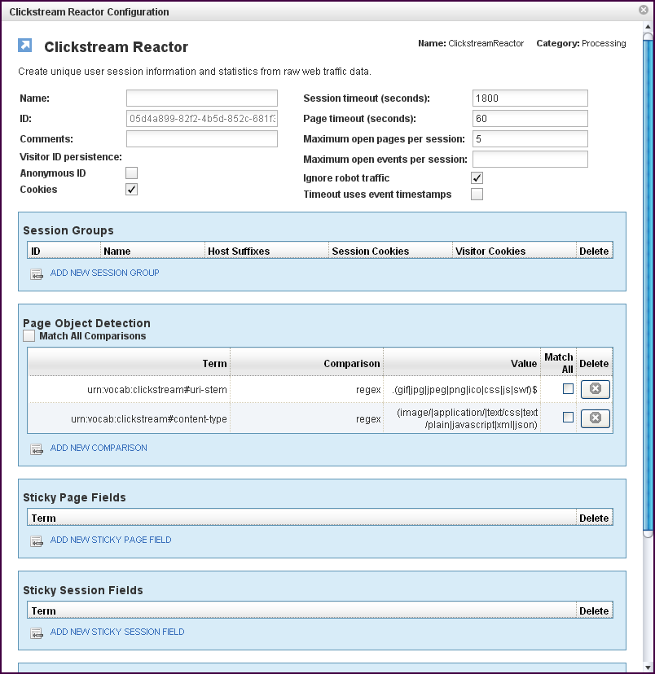
In addition to the fields you saw when adding the reactor initially (described above), you will see some additional fields and sections for Session Groups, Page Object Detection, Sticky Page Fields and Sticky Session Fields, and Connections (not shown above). The additional fields are:
Field | Description
ID | The reactor ID, a unique user-defined ID. This ID identifies a particular reactor.
Visitor ID Persistence | Allows Pion to detect repeat visitors (across sessions) and tag all the associated events (session-events, page-events and request-events) with a common "visitor-id" field so that they can be matched.  Two local databases are created and used to perform this mapping, one for "anonymous visitors" (visitors who have no cookie defined so they are identified only by IP address and user agent), and "Cookied Visitors" (visitors that do have a defined cookie).  This area contains two checkboxes:  - Anonymous ID  Fill this check box to cause all visitors with the same 16 bits of IP address and user-agent to be tagged with the same "visitor-id."  Note: This method of ID persistence is fairly inaccurate, and should be used only if no cookies are available.)  - Cookies  Fill this check box to cause repeat visitors with the same cookie values (for "visitor cookies" defined below in the session groups) to be tagged with the same visitor-id.  This is the default and is the recommended setting unless are certain that you don't need it.
Maximum open events per session | If the total number of events being cached for a particular session exceeds this value, it forces the oldest page to close and flush the associated events. This is basically a sanity check to make sure events caused by spiders and other non-human visitors don't consume too much memory.
Ignore robot traffic (check box) | When this check box is filled, all sessions detected as "robots" or "spiders" are discarded by the Clickstream Reactor.  When this check box is empty, events from sessions detected as "robots" or "spiders" are tagged with the "robot" field, but are not be discarded. A configuration file, "robots.xml" is used to control how Clickstream Reactor detects "robots."
Timeout uses event timestamps (check box) | When this check box is filled, page and session timeouts use the timestamps from events rather than system clock times to determine age.  When using PCAP file (with Sniffer Reactor) or web server log file (with Log File Input Reactor), this check box should always be filled.  When using live network interfaces, this check box should always be empty.

The Session Groups Section
The Session Groups section describes criteria which are used to determine sessions (to sessionize events).
Field | Description
ID | A short identifier that is assigned by Pion to the session-group field in all corresponding events.  A "default" identifier is reserved for use by the default session group. Sessions that do not match the Host Suffixes of any other groups will be assigned to the "default" group, regardless of the Host HTTP request header.  Note that a "default" session group is automatically generated (without cookies or host suffixes) if one is not otherwise specified in the configuration.
Name | A descriptive name for the session group.
Host Suffixes | Used to evaluate the Host HTTP request header to determine if an event belongs to this session group. Host suffixes are specified as a comma-separated list. One or more suffixes must be defined for each session group.  Note that, if a suffix of "atomiclabs.com" is specified, "atomiclabs.com" will match, and so would "pion.atomiclabs.com" and "www.atomiclabs.com" as well.
Session Cookies | Used to sessionize traffic, the names of these cookies are specified in a comma-separated list. For session cookies, you should only specify the names of cookies which have a lifetime of only the current session. Cookies of this type are discarded after the session expires.
Visitor Cookies | Used to sessionize traffic, the names of these cookies are specified in a comma-separated list. For visitor cookies, you should specify the names of cookies which have a lifetime that lasts beyond the current session.  These cookies are used for repeat-visitor detection (see "Visitor ID Persistence“ above). If the visitor returns the next day with the same visitor cookie, they will get tagged with the same visitor id (assuming "Cookies" visitor ID persistence is enabled above).  Visitor cookies are persisted in an embedded cookies database within Pion. The cookies database contains a timestamp, and can be pruned using the purge_cookies.pl script.
To add a Session Group, click on the ADD NEW SESSION GROUP link. The Session Group Initialization screen appears.
To delete a Session Group, click on the “x” at the end of the row describing that Session Group.

The Page Object Detection Section
The Page Object Detection section describes conditions that must be met in order for an event to be considered a valid page object. This section works in the same manner as a comparison (a Filter Rule Chain), see "ComparisonsX“ on page X36X for more information. If the event matches the comparison criteria, then the http request is considered to be a "page object" or component of another page view request. If the event does not match the comparison criteria, then the http request is considered to represent a new page view.
Field | Description
Match All Comparisons (check box) | When filled, indicates that ALL of the comparisons defined below must be matched.
Term | Defines the value of the term to be used for the comparison logic. Specifies the data item to find. You can select a term (an identified data item) from an existing vocabulary, or you can add a new vocabulary and define the term(s) to be found.
Comparison | Specifies the type of comparison to test, such as true/false or is-defined/is-not-defined.  Depending on the term that is specified in a row, an appropriate list of comparisons will appear in the comparison cell of that row. For example, if it's a date type, you'll get choices like "earlier than", whereas if it's a string type, you'll get choices like "starts with".  Like most comparisons, these two examples require a value to compare against, but a few comparisons, like “is defined,” do not require a value to compare against.  For more information on comparisons, see "ComparisonsX“ on page 36X.
Value
Match All (check box) | When filled, indicates that AT LEAST this comparison must be matched.
To add a row for a new comparison in the Page Object Detection section, click on the ADD NEW COMPARISON link.
To delete a Page Object Detection comparison, click on the “x” at the end of the row describing that comparison.

The Sticky Page Fields Section
The Sticky Page Fields section describes a list of terms to be copied from http-events into page-events.
Field | Description
Term | Defines the name of the Term to be copied from http events into page events.  Note that Sticky Page Fields work in a similar fashion as the "Terms to copy" section of the Fission Reactor.

To add a new Sticky Page Field, click on the ADD NEW STICKY PAGE FIELD link.
To delete a Sticky Page Field, click on the “x” at the end of the row describing that field.

The Sticky Session Fields Section
The Sticky Session Fields section describes a list of terms to be copied from page-events into session-events.
Field | Description
Term | Defines the name of the Term to be copied from page events into session events.  Note that Sticky Page Fields work in a similar fashion as the "Terms to copy" section of the Fission Reactor.
To add a new Sticky Session Field, click on the ADD NEW STICKY SESSION FIELD link.
To delete a Sticky Session Field, click on the “x” at the end of the row describing that field.

The Connections Section
The Connections section describes input and output connections for this Clickstream Reactor. See “Reactor Input and Output Connections“X on page X37X for more information.

Content Hash Reactor
The Content Hash Reactor creates and then stores an md5 hash as an identifier (a content_id) for a specified content term in an HTTP response. This identifier is stored in a database, which is then used by the Replay feature when reviewing the user experience.
When you add a Content Hash Reactor you will be prompted for the following fields:
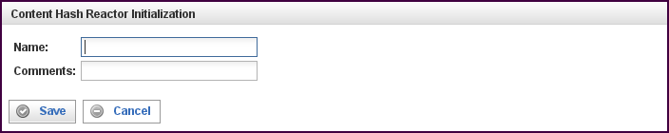

Field | Description
Name | Specify the name of this reactor. This can be any name you find descriptive, we recommend something which describes the data this reactor is processing.  The name may be any combination of letters and numbers.
Comments | Enter some descriptive comments about this reactor. Any comment you feel will help you in the future, we recommend choosing something that describes the data being processed.
This creates the Content Hash Reactor in the workspace. Double-clicking on the reactor brings you to the configuration screen:
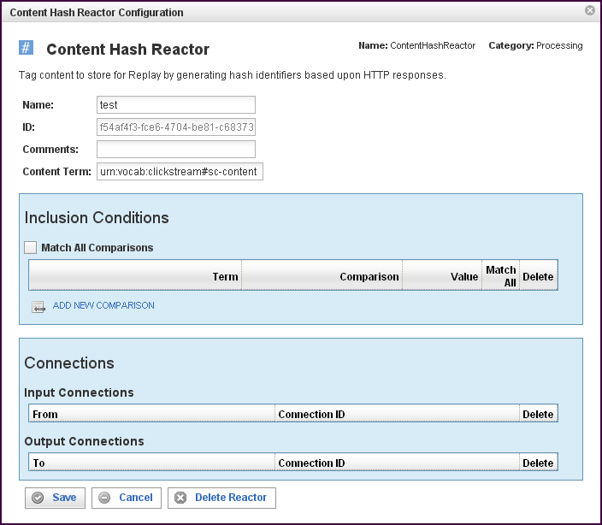
In addition to the fields you saw when adding the reactor initially (described above), you will see some additional fields and sections for Inclusion Conditions and Connections. The additional fields are:
Field | Description
ID | The reactor ID, a unique ID generated by the Pion server. This ID identifies a particular reactor.
Content Term | The source term used to generate a content hash identifier.

The Inclusion Conditions Section
The Inclusion Conditions section describes conditions that must be met in order for a prospective Content Term to be considered a new Content Term (which causes a new identifier to be generated). This section works in the same manner as a comparison (a Filter Rule Chain), see “Comparisons“X on page X36X for more information.
If an event both contains a value for the Content Term and matches the Inclusion Conditions, a hash identifier will be generated and added to the event.
If the event does not contain a value for the Content Term or it does not match the Inclusion Conditions, the event is delivered to the reactor's output connections unmodified.
Field | Description
Match All Comparisons (check box) | When filled, indicates that ALL of the comparisons defined below must be matched.
Term | Defines the value of the term to be used for the comparison logic. Specifies the data item to find. You can select a term (an identified data item) from an existing vocabulary, or you can add a new vocabulary and define the term(s) to be found.
Comparison | Specifies the type of comparison to test, such as true/false or is-defined/is-not-defined.  Depending on the term that is specified in a row, an appropriate list of comparisons will appear in the comparison cell of that row. For example, if it's a date type, you'll get choices like "earlier than", whereas if it's a string type, you'll get choices like "starts with".  Like most comparisons, these two examples require a value to compare against, but a few comparisons, like “is defined,” do not require a value to compare against.  For more information on comparisons, see “ComparisonsX”“ on page 36X.
Value
Match All (check box) | When filled, indicates that AT LEAST this comparison must be matched.
To add a row for a new comparison in the Inclusion Conditions section, click on the ADD NEW COMPARISON link.
To delete a comparison, click on the “x” at the end of the row describing that comparison.

The Connections Section
The Connections section describes input and output connections for this Content Hash Reactor. See “Reactor Input and Output Connections“X on page X37X for more information.

Filter Reactor
The Filter Reactor can filter in or out any information based on any number of criteria you might set. For example, you could do something simple like only looking at a particular set of users of web servers. Or you could do something much more complicated such as only tracking certain individuals who are spending more than $50 on kitchen ware in their sessions.
When you add a Filter Reactor you will be prompted for the following fields:
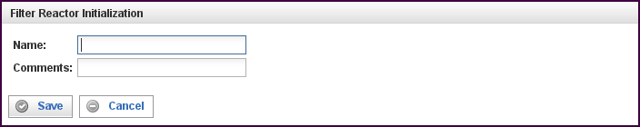

Field | Description
Name | Specify the name of this reactor. This can be any name you find descriptive, we recommend something which describes the data this reactor is processing.  The name may be any combination of letters and numbers.
Comments | Enter some descriptive comments about this reactor. Any comment you feel will help you in the future, we recommend choosing something that describes the data being processed.
This creates the Filter Reactor in the workspace. Double-clicking on the reactor brings you to the configuration screen:
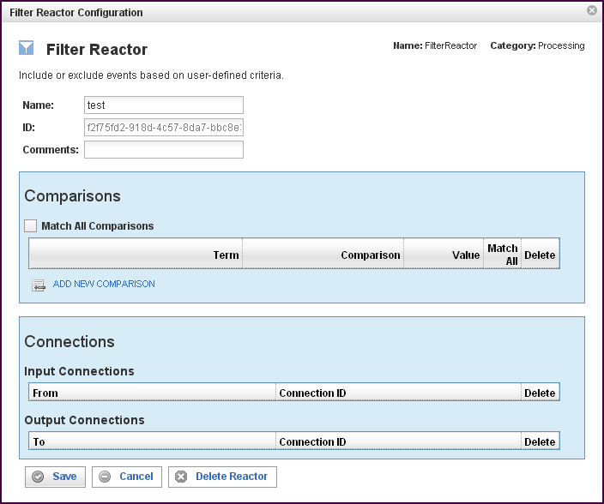

In addition to the fields you saw when adding the reactor initially (described above), you will see some additional fields and sections for Comparisons and Connections. The additional fields are:
Field | Description
ID | The reactor ID, a unique ID generated by the Pion server. This ID identifies a particular reactor.

The Comparisons Section
The Comparisons section describes the comparisons to be made in this Filter Reactor. If the event matches the comparison criteria, it will be delivered to all Output Connections. If the event does not match the comparison criteria, it is dropped. See “Comparisons“X on page 36X for more information.

Field | Description
Match All (check box) | When filled, indicates that ALL of the comparisons defined below must be matched.
Term | Defines the value of the term to be used for the comparison logic. Specifies the data item to find. You can select a term (an identified data item) from an existing vocabulary, or you can add a new vocabulary and define the term(s) to be found.
Comparison | Specifies the type of comparison to test, such as true/false or is-defined/is-not-defined.  Depending on the term that is specified in a row, an appropriate list of comparisons will appear in the comparison cell of that row. For example, if it's a date type, you'll get choices like "earlier than", whereas if it's a string type, you'll get choices like "starts with".  Like most comparisons, these two examples require a value to compare against, but a few comparisons, like “is defined,” do not require a value to compare against.  For more information on comparisons, see “Comparisons“ on page 36X.
Value
Match All (check box) | When filled, indicates that AT LEAST this comparison must be matched.
To add a row for a new comparison in the Comparison section, click on the ADD NEW COMPARISON link.
To delete a comparison, click on the “x” at the end of the row describing that comparison.

The Connections Section
The Connections section describes input and output connections for this Filter Reactor. See “Reactor Input and Output Connections” on page X37X for more information.

Fission Reactor
Filter Reactor, splits input events into sequences of output events based on any number of criteria you might set.
When you add a Fission Reactor you will be prompted for the following fields:
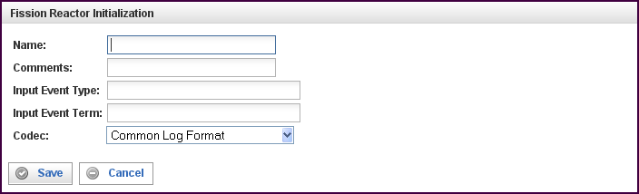

Field | Description
Name | Specify the name of this reactor. This can be any name you find descriptive, we recommend something which describes the data this reactor is processing.  The name may be any combination of letters and numbers.
Comments | Enter some descriptive comments about this reactor. Any comment you feel will help you in the future, we recommend choosing something that describes the data being processed.
Input Event Type | The input event type must be a Term of type “object” (this rule is enforced by the Pion user interface). Only input events of this type are processed; any other events are dropped.  An Input Event Type must be specified.
Input Event Term | A term to be parsed from the Input Event (described above). The type of the input event term must be one of the string types (this rule is enforced by the Pion user interface). One or more values from each Input Event Term in the input event are parsed by the Codec to create output events.  An Input Event Term must be specified.
Codec | Defines the codec used to parse the Input Event Term(s) specified above.  A Codec must be specified.
This creates the Fission Reactor in the workspace. Double-clicking on the reactor brings you to the configuration screen:
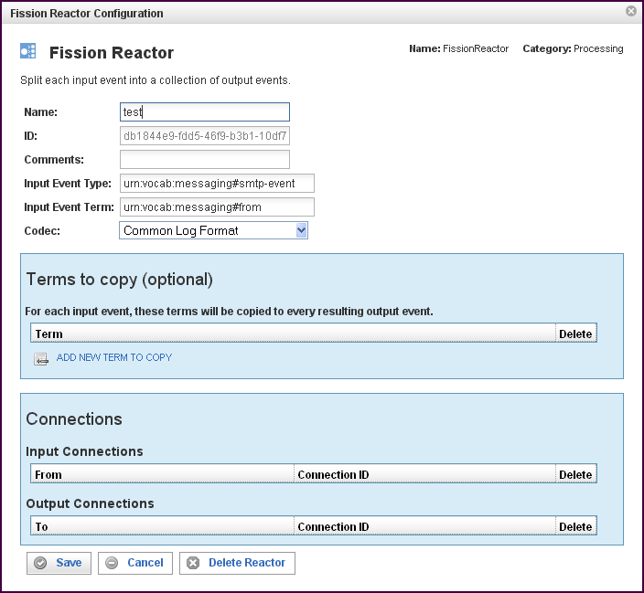
In addition to the fields you saw when adding the reactor initially (described above), you will see some additional fields and sections for Terms to copy and Connections. The additional fields are:
Field | Description
ID | The reactor ID, a unique ID generated by the Pion server. This ID identifies a particular reactor.

The Terms to Copy Section
The Inclusion Conditions section describes a list of terms whose values will be copied into all output events.
Field | Description
Terms (to copy) | The value or values of each of the terms defined will be copied from the original event into all derived events.
To add a new term in the Terms to copy list, click on the ADD NEW TERM TO COPY link. When you click on the new row, a list of vocabularies and their associated terms appears. Select the vocabulary and term you want to add, then click Select term.
To delete a term from the list, click on the “x” at the end of the row containing that term.

The Connections Section
The Connections section describes input and output connections for this Fission Reactor. See “Reactor Input and Output ConnectionsX“ on page X37X for more information.

Python Reactor
The Python Reactor allows you to use the popular Python programming language to collect, manipulate and store events within Pion.
When you add a Python Reactor you will be prompted for the following fields:
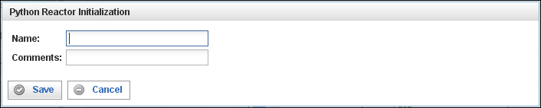
Field | Description
Name | Specify the name of this reactor. This can be any name you find descriptive, we recommend something which describes the data this reactor is processing.  The name may be any combination of letters and numbers.
Comments | Enter some descriptive comments about this reactor. Any comment you feel will help you in the future, we recommend choosing something that describes the data being processed.

This creates the Python Reactor in the workspace. Double-clicking on the reactor brings you to the configuration screen:
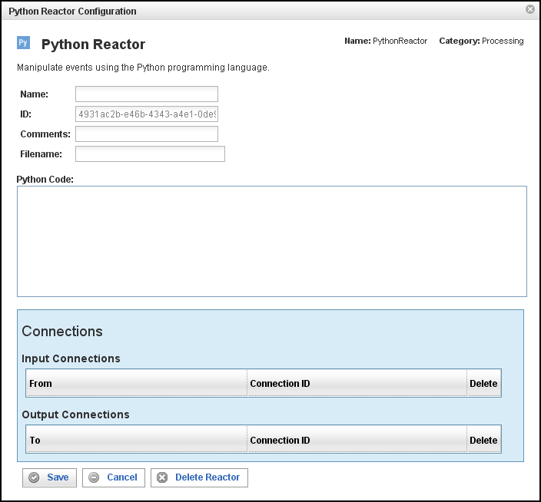
In addition to the fields you saw when adding the reactor initially (described above), you will see one additional field and the Connections section. The additional field is:
Field | Description
ID | The reactor ID, a unique ID generated by the Pion server. This ID identifies a particular reactor.
Filename | If specified, this file should contain the Python source code used to manipulate events.
Python Code | If a file name is not specified above, you may enter your Python code into this box (see About Your Source Code in the Python Reactor, below). Code in this box is ignored if a file name is specified above.

About Your Source Code in the Python Reactor
The Python Reactor automatically compiles your source code into a byte code format that is stored in memory. Your code is automatically imported into a Pion module which supports two special data types, Event and Reactor, and three "callback" functions, start(), stop(), and process().

The Event Data Type
The Event data type is a subclass of the Python dict (dictionary) type. It contains one additional attribute:
(name / type / description)
-------------------------------
type str type of Event (i.e. "urn:vocab:clickstream#http-event")

Events must always have a valid "type" (as configured in a Pion vocabulary). The keys of Event items must be string types representing a particular Term identifier (i.e. "urn:vocab:clickstream#uri-stem"). The value of an Event item must be a Python sequence (tuple or list) containing zero or more objects (note that in most cases it will contain a single item). All objects in a value sequence must be of a type corresponding to the Pion data type assigned to the corresponding Term.
The following are the Python types that correspond to Pion Vocabulary data types:
Pion Type | Python Type
undefined | int = 1
event type | int = 1
signed int (8-bit) | int
positive int (8-bit) | int
signed int (16-bit) | int
positive int (16-bit) | int
signed int (32-bit) | int
positive int (32-bit) | long
signed int (64-bit) | long
positive int (64-bit) | long
small real number | float
medium real number | float
large real number | float
small string | str
medium string | str
large string | str
fixed-length string | str
binary large object | str
blob (stored compressed) | str
specific date | date
specific time | time
specific time & date | datetime

The Reactor Data Type
The Reactor data type supports the attributes “id,” “name,” and “deliver” where:
- id: Is a string (str) value of the unique identifier of the Python Reactor.
- name: Is a string (str) value of the name assigned to the Python Reactor.
- deliver: Is a function that takes a single Event object argument, and delivers the event to all of the Python Reactor's output connections.

The Callback Functions
The following three callback functions are optional, and can be used to define the behavior of this reactor:
- start(Reactor)
Pion calls this function whenever the reactor is started. It is given a single parameter, a Reactor object representing the Python Reactor.
- stop(Reactor)
Pion calls this function whenever the reactor is stopped. It is given a single parameter, a Reactor object representing the Python Reactor.
- process(Reactor, Event)
Pion calls this function whenever the reactor receives a new event to process via an input connection. The first parameter is a Reactor object ID representing the Python Reactor. The second parameter is an Event object representing the original Pion event.
- If no process() function is provided, the Python Reactor passes all events it receives to its output connections without modification.
- If a process() function is defined, you must explicitly deliver any events to the reactor's output connections by calling the deliver method of the Reactor object ("r.deliver(e)").
Any exceptions raised by a custom process() function will result in an ERROR message being logged and the event being dropped.
The following is an example of callback functions that can be used by the Python Reactor:
URI_STEM = 'urn:vocab:clickstream#uri-stem'

def start(r):
print 'starting reactor', r.name

def stop(r):
print 'starting reactor', r.name

def process(r, e):
print 'reactor', r.name, 'received an event of type', e.type
e[URI_STEM] = ['/new_uri_stem']
r.deliver(e)
Note that all code defined outside of the three callback functions will be executed when the reactor starts. Any classes or functions defined are reusable by the callback functions, and any attributes persist until the reactor is stopped.
For more information on the Python programming language, please see: http://www.python.org or the many books available.

The Connections Section
The Connections section describes input and output connections for this Python Reactor. See “Reactor Input and Output ConnectionsX”“ on page X37X for more information.

Script Reactor
The Script Reactor enables you to leverage existing command line scripts to quickly add capabilities to Pion. Through the use of the script reactor you can do things such as create follow-up queues based on customer behavior or retrieve additional information from disparate sources on the fly.
When you add a Script Reactor you will be prompted for the following fields:
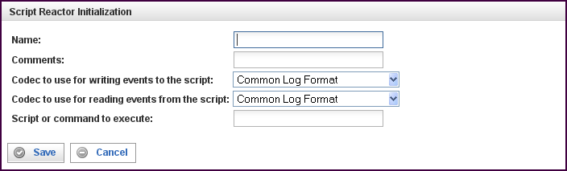

Field | Description
Name | Specify the name of this reactor. This can be any name you find descriptive, we recommend something which describes the data this reactor is processing.  The name may be any combination of letters and numbers.
Comments | Enter some descriptive comments about this reactor. Any comment you feel will help you in the future, we recommend choosing something that describes the data being processed.
Codec to use for writing events to the script | Events from other reactors will be delivered to the script's stdin file descriptor. These events will be serialized using the specified codec.
Codec to use for reading events from the script | Events going to other reactors from this Script Reactor will be read using the script's stdout file descriptor. These events will be serialized using the specified codec.
Script or command to execute | When running, the Script Reactor will execute the command specified and pipe events through the command. The command is executed once and will remain running until the reactor is stopped (or the command terminates by itself).

This creates the Script Reactor in the workspace. Double-clicking on the reactor brings you to the configuration screen:
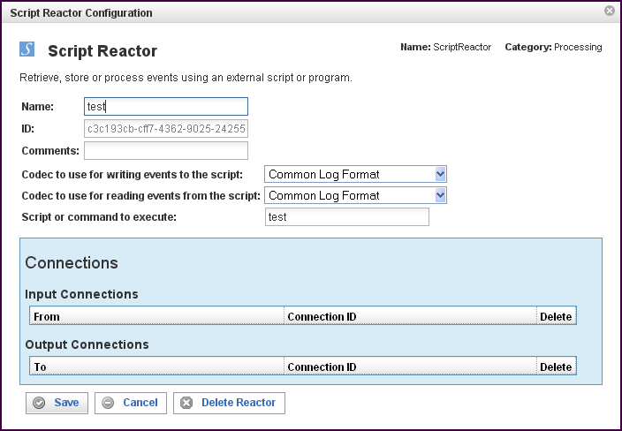
In addition to the fields you saw when adding the reactor initially (described above), you will see one additional field and the Connections section. The additional field is:
Field | Description
ID | The reactor ID, a unique ID generated by the Pion server. This ID identifies a particular reactor.

The Connections Section
The Connections section describes input and output connections for this Script Reactor. See “Reactor Input and Output ConnectionsX”“ on page X37X for more information.

Session Filter Reactor
The Session Filter Reactor enables you to hold entire sessions until they meet certain criteria. The Session Filter Reactor must always be used after a Clickstream Reactor to ensure that the sessions are created. Using the Session Filter Reactor, you can do things such as saving full page view detail on only users that purchased a certain book or encountered an error.
When you add a Filter Reactor you will be prompted for the following fields:
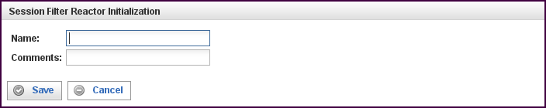

Field | Description
Name | Specify the name of this reactor. This can be any name you find descriptive, we recommend something which describes the data this reactor is processing.  The name may be any combination of letters and numbers.
Comments | Enter some descriptive comments about this reactor. Any comment you feel will help you in the future, we recommend choosing something that describes the sessions being held.
This creates the Filter Reactor in the workspace. Double-clicking on the reactor brings you to the configuration screen:
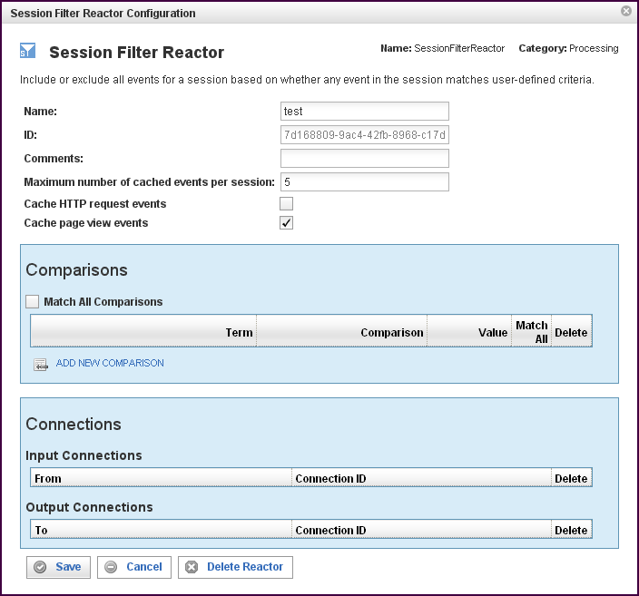

In addition to the fields you saw when adding the reactor initially (described above), you will see some additional fields and sections for Comparisons and Connections. The additional fields are:
Field | Description
ID | The reactor ID, a unique ID generated by the Pion server. This ID identifies a particular reactor.
Maximum number of cached events per session | Specifies the maximum number of cached events per session. If the total number of cached events (individual HTTP requests AND page view events) for a particular session exceeds this value, the oldest events are discarded.  This essentially creates a "rolling window" of events leading up to the point where the session passes the comparison rules. All events for the session are delivered immediately after the comparison rules are met (without caching).  Setting this value to 0 will cache all events indefinitely, but we strongly recommend that a reasonable maximum be defined unless you have VERY little traffic, because this can otherwise quickly consume all the memory available.
Cache HTTP request events (check box) | When the check box is filled, HTTP request events are cached until the comparisons are met. After the comparisons are met, all events for the session are delivered immediately.
Cache page view events (check box) | When the check box is filled, page view events are cached until the comparisons are met. After the comparisons are met, all events for the session are delivered immediately.

The Comparisons Section
The Comparisons section describes comparison to be made in this Session Filter Reactor. See “Comparisons“X on page X36X for more information.
Field | Description
Match All (check box) | When filled, indicates that ALL of the comparisons defined below must be matched.
Term | Defines the value of the term to be used for the comparison logic. Specifies the data item to find. You can select a term (an identified data item) from an existing vocabulary, or you can add a new vocabulary and define the term(s) to be found.
Comparison | Specifies the type of comparison to test, such as true/false or is-defined/is-not-defined.  Depending on the term that is specified in a row, an appropriate list of comparisons will appear in the comparison cell of that row. For example, if it's a date type, you'll get choices like "earlier than", whereas if it's a string type, you'll get choices like "starts with".  Like most comparisons, these two examples require a value to compare against, but a few comparisons, like “is defined,” do not require a value to compare against.  For more information on comparisons, see “Comparisons“X on page 36X.
Value
Match All (check box) | When filled, indicates that AT LEAST this comparison must be matched.
To add a row for a new comparison in the Comparison section, click on the ADD NEW COMPARISON link.
To delete a comparison, click on the “x” at the end of the row describing that comparison.

The Connections Section
The Connections section describes input and output connections for this Session Filter Reactor. See ”Reactor Input and Output ConnectionsX“ on page X37X for more information.

SQL Reactor
SQL Reactor, which lets Pion interact with any relational database based on real time information. This means that Pion can gather additional information on sessions based on past activity. For example, you can see how much a customer spent during the last 2 years to add context to their session and to improve segmentation for analytics. Based on real-time information, the SQL Reactor can also update or insert data in the database to ensure that the information you have is always the most current possible.
When you add a SQL Reactor you will be prompted for the following fields:
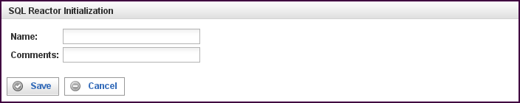

Field | Description
Name | Specify the name of this reactor. This can be any name you find descriptive, we recommend something which describes the data this reactor is processing.  The name may be any combination of letters and numbers.
Comments | Enter some descriptive comments about this reactor. Any comment you feel will help you in the future, we recommend choosing something that describes the data being processed.
This creates the SQL Reactor in the workspace. Double-clicking on the reactor brings you to the configuration screen:
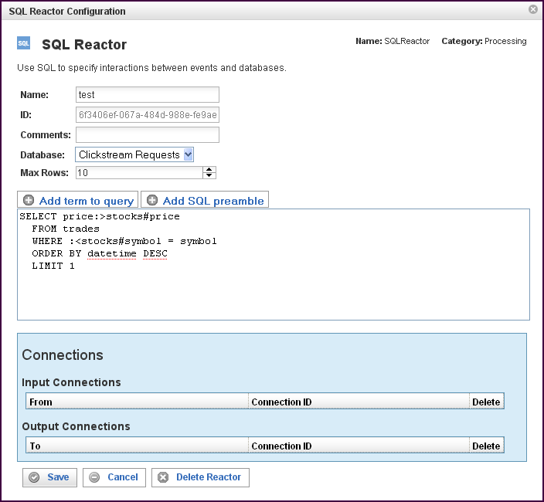

In addition to the fields you saw when adding the reactor initially (described above), you will see some additional fields and sections for Comparisons and Connections. The additional fields are:
Field | Description
ID | The reactor ID, a unique ID generated by the Pion server. This ID identifies a particular reactor.
Database | The database on which queries are executed.
Max Rows | The maximum number of rows allowed in a result set, limiting the size of a result set.  One of the most damaging aspects of database query results is the possibility of a large result set size, which generally locks the table, or consumes resources until the result set has been transferred. Even though is advisable to put a LIMIT n statement into the query to limit the result set size, Pion allows you to define the result set size using Max Rows. When Max Rows is specified, after n results have been received and processed into the event, the rest of the result set is discarded and resources are freed.
Add term to query | When selected, opens up a term selector dialog, exposing the available vocabularies and the terms in the vocabularies. When a term is selected, shorthand notation is inserted into the query.  Preface the term with ":<" for input, or ":>" for output.
Add SQL preamble | The SQL preamble allows you to configuring a set of SQL queries. The SQL queries in the SQL preamble are executed as the SQL Reactor starts. The SQL preamble is commonly used to establish things such as:  Pragma's (in SQLite); to limit result set, locking, caching, etc.  Views, if you are using materialized views.  Keep-connection-open configurations.  Linking tables in MySQL(federated tables) or SQLite (attaching databases).
The SQL query | The SQL query to be executed, in "Pion SQL."  In the sample above:  SELECT price:>stocks#price  FROM trades  WHERE :<stocks#symbol = symbol  ORDER BY datetime DESC  LIMIT 1  The table "trades" is assumed to be available via the database connection.  The columns "price" and "symbol" are assumed to exist in the “trades” table.  A query is executed using the Pion term "urn:vocab:stocks#symbol" (represented in short-hand form as "stocks#symbol").  The term stocks#symbol is used as an INPUT parameter (":<" denotes input), meaning that the statement ":<stocks#symbol" will be replaced with the actual value of the term, in a SQL injection safe manner.  The value of the column "price" will be put into the Pion term "stocks#price" (the full Pion notation is “urn:vocab:stocks#price" upon result.  Note: If more than one line were permitted (LIMIT 1), the term stocks#price may contain multiple values.  There is no practical limit of number of parameters that can be passed into the database, nor a limit on parameters coming back.  Note: There is no inherent requirement that the query is actually a query (SELECT). Instead, the SQL statement can be:  INSERT: "INSERT INTO trades VALUES (:<stocks#symbol,:<stocks#price)  DELETE: "DELETE FROM trades WHERE symbol = :<stocks#symbol"  Also, note that a table name is not required at all, the SQL Reactor can be used against "DUAL" or shadow table:  "SELECT :<stocks#price + :<stocks#price :>stocks#price"  Which effectively will take the stocks#price and multiply by two.  The same method can be used for tricks, such as concatenating strings, doing string functions, math, etc. Remember that the actual code is dependent on the flavor of SQL used.  Pion has a complete version of SQLite embedded, which provides a rich set of math, string, and date functions.

The Connections Section
The Connections section describes input and output connections for this SQL Reactor. See ”Reactor Input and Output ConnectionsX“ on page X37X for more information.

Transform Reactor
Transform Reactor, which is able to do deep manipulation of the data in the data stream. For example, this can be as simple as formatting a URL to be something more easily readable or consistent if sites are constantly changing, or calculating dollar values from a page to see total spend (even taking into account if the currency must be converted). Because the Transform Reactor is very flexible, it can also do more complex things such as capturing and translating a bank branch or user identification on the fly.
Note: An event processed by the Transform Reactor is transformed. The original (unmodified) event is not passed through. The Transform Reactor’s only output is transformed events. If the original (unmodified) event is desired, make an additional connection from the reactor preceding the Transform Reactor to the reactor(s) following the Transform Reactor.
When you add a Transform Reactor you will be prompted for the following fields:
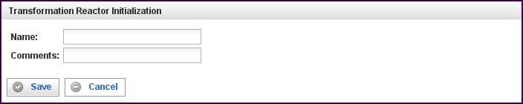

Field | Description
Name | Specify the name of this reactor. This can be any name you find descriptive, we recommend something which describes the data this reactor is processing.  The name may be any combination of letters and numbers.
Comments | Enter some descriptive comments about this reactor. Any comment you feel will help you in the future, we recommend choosing something that describes the data being processed.
This creates the Transform Reactor in the workspace. Double-clicking on the reactor brings you to the configuration screen: this reactor gets
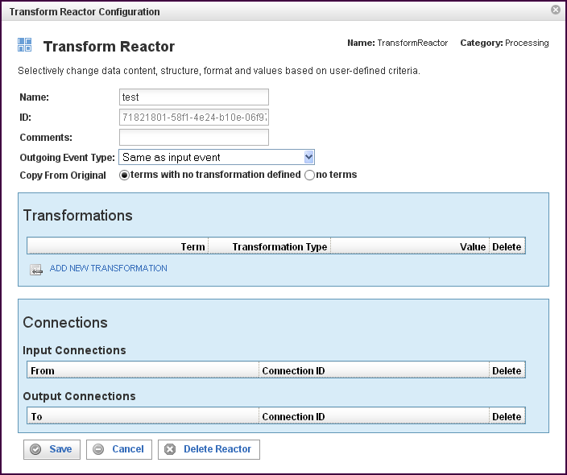

In addition to the fields you saw when adding the reactor initially (described above), you will see some additional fields and sections for Transformations and Connections. The additional fields are:
Field | Description
ID | The reactor ID, a unique ID generated by the Pion server. This ID identifies a particular reactor.
Outgoing Event Type | Event that is output (transformed) may either be of same type as the incoming event, or a user definable type.
Copy From Original | Terms (fields) in the original event are:  Copied-if-not-present. Copy all the terms for which there are no transformations. Note that transformations are not always successful, so some terms with transformations may not exist in the output event (example: lookup, with a failure and no default).  Not copied. Only terms that are transformed are copied, and if there is no transformation, the term will not exist in the transformed event.  Copied in full, and transformations *add* to the copied terms.  Note: Do not use unless you know how to handle multiple values on terms. This option is now deprecated.

The Transformations Section
The Transformations section describes the transformation processing to be done on the term(s).
Field | Description
Term | Defines the name of the term that will be set to the resulting value of the Transformation Rule. You can select a term (an identified data item) from an existing vocabulary, or you can add a new vocabulary and define the term(s) to be found.
Transformation Type | Depending on the vocabulary and term selected, there are transformation types available:  - AssignValue  Assigns a constant value to the term defined. Appropriate lexical casting is performed, converting the value to a string, numeric or date value as appropriate. AssignValue will fail to assign only if the cast fails (for example a text string into a numeric value).  - AssignTerm  Assigns a source term (from the original event) to a destination term (resulting event). The value is re-cast, allowing type conversions (text to numeric, or numeric to text). AssignTerm will fail to create the destination term if the source term does not exist, or if the transformation fails to cast. If there are multiple matching source terms, all are copied to destination.  - Lookup  Applies a regular expression (optional) with a format string (optional, default $&) to a source term (the original event), producing a key. The key is applied (case sensitive) against a table of key/value pairs.  If a matching key is found, the value is used.  If a key is not found, one of the default actions is taken.  If the key is left undefined, the original (pre-regex) value is used with the regex 'p'd (post-regex) value, and a fixed value is used. The result is cast and assigned. Lookup is repeated for each matching source term.  - Rules  [StopOnFirstMatch] Rules will either execute through all rules in a transformation, or stop on the first successfully matched rule. The source term (original event), is matched against a comparison, which can be any of the normal comparisons, true/false/defined/less-than/is-equal/etc...  If the comparison succeeds, the SetValue is assigned like AssignValue.  If the comparison fails, the regex is evaluated, and SetValue defines the output format.  Note: Not-RegExp assigns SetValue as a literal, since the regex failed.  Note: To copy source-term value(s), use RegExp with ".*" (true will assign a literal value).  If source term has multiple values, the rule is applied to each value individually (StopOnFirstMatch does not apply to multiple term values).  If a rule was successful (even for one term value), and StopOnFirstMatch was defined, processing of rules stops.  Setting StopOnFirstMatch not true will cause many values to be compounded in a destination term. This setting is useful for "adding tags" to a term.  Note: Use with caution!  Assignment of values (SetValue or RegExp/format-output) is re-cast and assigned.  Note. All rules, all conditions always use the source term from the original event. Multi-step, or progressive processing can only be done with successive separate Transform Reactors.  - Regex  Uses a source term (must be of string type), and executes a number of regular expressions (with optional format strings). For each regular expression, if the expression fails, the source value (for the expression) is used instead of a transformed value. Expressions are executed for each value in the source term individually, and the resulting strings are copied to the destination term.  Note: Both Lookup and Rules already have a regex, this is a serial regex.  The non-use of StopOnFirstMatch (short-circuit) in Rules is available, and can be used when creating "tag lists" in terms. Do not, however, uncheck it if you don't know how to use the result.
Value | The meaning of this column differs based upon the Transformation Type selected. This allows you to input a value for "AssignValue", select a term for "AssignTerm", and opens additional configuration windows for Lookup, Rules and Regex.
To add a row for a new transformation in the Transformations section, click on the ADD NEW transformation link.
To delete a transformation, click on the “x” at the end of the row describing that term.

58BURegular Expressions in the Transform Reactor
The Transform Reactor uses regex in three different ways:
- In Lookup, regex can be used initially
- In Rules, regex is one of the many options
- In Regex, regex is used in a successive manner
In all cases, the regex being used is the Boost.org regex.
For more information about the basic (Perl) regex by boost, see:
http://www.boost.org/doc/libs/1_39_0/libs/regex/doc/html/boost_regex/syntax/perl_syntax.htmlH.
For information on the format string as it is used in the regular expressions, see:
http://www.boost.org/doc/libs/1_39_0/libs/regex/doc/html/boost_regex/format/perl_format.htmlH.

The Connections Section
The Connections section describes input and output connections for this Transform Reactor. See “Reactor Input and Output Connections“X” on page X37X for more information.

Storage Reactors
Storage Reactors are needed whenever data needs to be kept for later use (for example reporting or record keeping). For web analytics to take place, a Pion workflow must always end with a Storage Reactor.
The Storage Reactors include:
- Database Output Reactor, which enables Pion to store information in almost any database.
- Google Analytics Reactor, which is able to take web user behavior information and send it to Google Analytics servers via its native web services interface in real-time.
- Log Output Reactor, which enables you to write any data to a structured flat file of your choice in real time.
- Multi Database Reactor, which enables Pion to store information in several databases (or several tables in a single database).
- Omniture Analytics Reactor, which is able to take web user behavior information and send it through the Omniture Analytics integration system to SiteCatalyst via its native web services interface (in real-time) or the XML loading interface.
These reactors are described in the following sections.

Database Output Reactor
The Database Output Reactor enables Pion to store information in almost any database. The Database Output Reactor handles the format translation, table organization and performance tuning aspects required to ensure Pion events are written with the best performance and quality possible. To ensure high performance, native database communication is available for MySQL, Oracle, Microsoft, Sybase, IBM, Informix, Centura, Interbase, PostgreSQL and SQL Lite databases. The Database Output Reactor can also send data to any ODBC compliant database for storage. Because Pion enables direct database output, it can be easily integrated into any business intelligence implementation or data warehouse without requiring custom code or a separate extract, transfer and load (ETL) tool.
When you add a Database Output Reactor you will be prompted for the following fields:
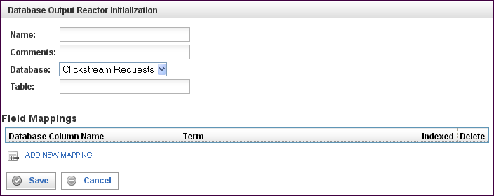

Field | Description
Name | Specify the name of this reactor. This can be any name you find descriptive, we recommend something which describes the data this reactor is storing.  The name may be any combination of letters and numbers.
Comments | Enter some descriptive comments about this reactor. Any comment you feel will help you in the future, we recommend choosing something that describes the data being stored.
Database | Select the database into which you want to write events.
Table | Specify the table in the database named above. The events will be written to this table.
This creates the Database Output Reactor in the workspace. Double-clicking on the reactor brings you to the configuration screen:
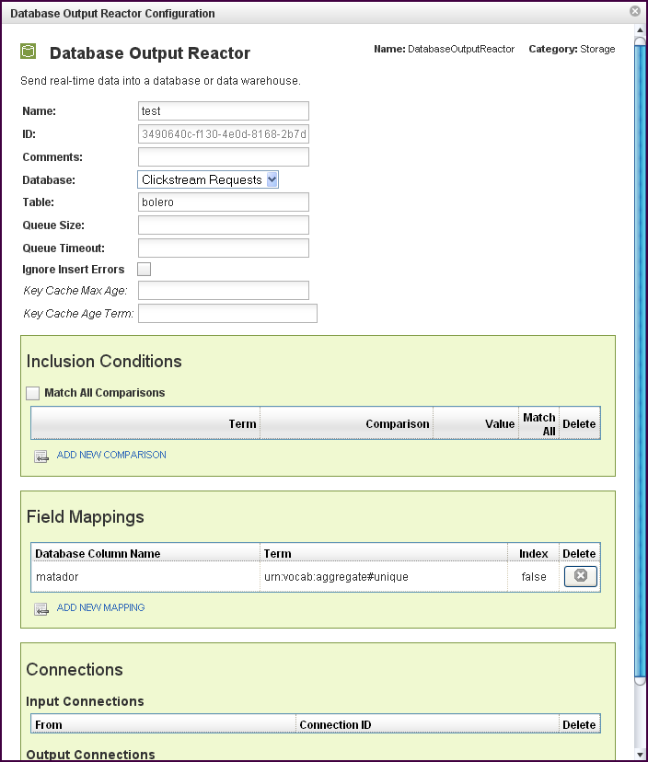
In addition to the fields you saw when adding the reactor initially (described above), you will see one additional field and the Inclusion Conditions, Field Mappings, and Connections sections.:
Field | Description
ID | The reactor ID, a unique ID generated by the Pion server. This ID identifies a particular reactor.
Queue Size | The number of events allowed in the queue before triggering a bulk insert to the table specified above. The default queue size is 1000 events.
Queue Timeout | The number of seconds to wait (the interval) before triggering a bulk insert to the table specified above. The default queue timeout is 10s (10 seconds).
Ignore Insert Errors (check box) | Inserts may fail if records already exist within the table which have the same unique index values. Fill this check box to ignore these errors.
Key Cache Max Age | Used only if a unique index is defined and this value is non-zero. Pion will maintain a memory-based cache of the most recent unique index values inserted into the database. Items in this cache are removed after the specified number of seconds has elapsed since the previous insert attempt.
Key Cache Age Term | If the key cache is enabled, this must be assigned to the event term corresponding to a timestamp for the epoch (for example urn:vocab:clickstream#epoch-time).

The Inclusion Conditions Section
The Inclusion Conditions section is used to specify the data (the terms) that are saved in the database specified. If the conditions are TRUE, the event will be inserted into the database table. If FALSE, the event will be discarded.
Field | Description
Match All Comparisons (check box) | When filled, indicates that ALL of the comparisons defined below must be matched.
Term | The vocabulary term whose value will be stored in the database column for each event inserted.
Comparison | Specifies the type of comparison to test, such as true/false or is-defined/is-not-defined.  Depending on the term that is specified in a row, an appropriate list of comparisons will appear in the comparison cell of that row. For example, if it's a date type, you'll get choices like "earlier than", whereas if it's a string type, you'll get choices like "starts with".  Like most comparisons, these two examples require a value to compare against, but a few comparisons, like “is defined,” do not require a value to compare against.  For more information on comparisons, see “Comparisons“X on page 36X.
Value
Match All (check box) | When filled, indicates that AT LEAST this comparison must be matched.
To delete a connection, click on the “x” at the end of the row describing that connection.

The Field Mappings Section
The Field Mappings section maps event vocabulary terms to database table columns..
Field | Description
Database Column Name | Specifies the name of the database column corresponding to the event term.
Term | The vocabulary term whose value will be stored in the database column for each event inserted.
Index | Controls database indexing settings. You can choose from any of the following:  True, which means an index is added to the database table for this field, making searches more efficient while making inserts less efficient. We strongly recommend this setting for all fields that you want to search using the Replay interface.  False, which means no index is used for this database field. We recommend this setting for all fields that you will not normally search using the Replay interface.  Unique, which means the database field is a unique index for the table.
To delete a field mapping, click on the “x” at the end of the row describing that mapping.

The Connections Section
The Connections section describes input and output connections for this Database Output Reactor. See “Reactor Input and Output Connections“X on page X37X for more information.

Google Analytics Reactor
The Google Analytics Reactor takes web user behavior information and sends it to Google Analytics servers via its native web services interface in real time. From Google Analytics perspective, data collected by Pion is indistinguishable from that collected via page tags. All you need to supply is the correct Google Analytics Account ID and site name to connect Pion to Google Analytics.
When you add a Google Analytics Reactor you will be prompted for the following fields:
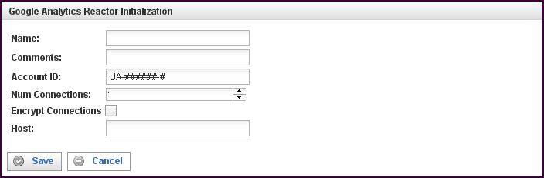

Field | Description
Name | Specify the name of this reactor. This can be any name you find descriptive, we recommend something which describes the data this reactor is processing.  The name may be any combination of letters and numbers.
Comments | Enter some descriptive comments about this reactor. Any comment you feel will help you in the future, we recommend choosing something that describes the data being stored.
Account ID | Your Google Analytics account number. This is typically displayed next to each host name for each of your website profiles, and begins with "UA-"
Num Connections | Specify the maximum number of concurrent threaded connections that will be established to deliver traffic to the Google Analytics servers.  One connection is sufficient for most websites, although sites with a large volume of traffic should increase this number accordingly.
Encrypt Connections (check box) | Fill this check box to encrypt connections between Pion and the Google Analytics servers. Normally this check box is not filled (encryption is not enabled).
Host | This can be used to override the Pion host name string delivered to the Google Analytics servers. Normally left blank.
This creates the Google Analytics Reactor in the workspace. Double-clicking on the reactor brings you to the configuration screen:
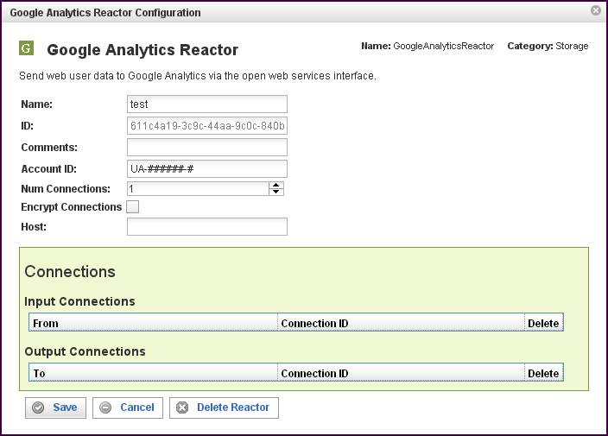
In addition to the fields you saw when adding the reactor initially (described above), you will see one additional field and the Connections section. The additional field is:
Field | Description
ID | The reactor ID, a unique ID generated by the Pion server. This ID identifies a particular reactor.

The Connections Section
The Connections section describes input and output connections for this Google Analytics Reactor. See “Reactor Input and Output Connections“X on page X37X for more information.

Log Output Reactor
The Log Output Reactor enables you to write any data to a structured flat file of your choice in real time. This is often very useful for web analytics, because most tools are written to take in web server files as their default input format. Pion can capture, process and enrich user information before creating the distilled log files for use by other tools. This enables Pion to easily integrate with almost any on-site web analytics package including the open source efforts.
When you add a Log Output Reactor you will be prompted for the following fields:
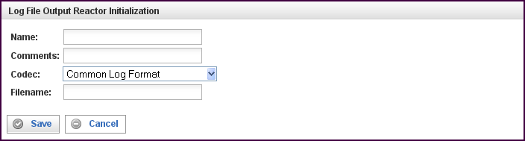

Field | Description
Name | Specify the name of this reactor. This can be any name you find descriptive, we recommend something which describes the data this reactor is processing.  The name may be any combination of letters and numbers.
Comments | Enter some descriptive comments about this reactor. Any comment you feel will help you in the future, we recommend choosing something that describes the data being stored.
Codec | The name of the codec that controls the output format used to write the data to the log file named in filename.
Filename | The name of the log file to which the data will be written.  This name may be fully qualified, or it may also be relative. When a relative file name is specified, the base path is equal to the "DataDirectory" defined in your platform.xml file. On Unix machines, this is /var/lib/pion/.

This creates the Log Output Reactor in the workspace. Double-clicking on the reactor brings you to the configuration screen:
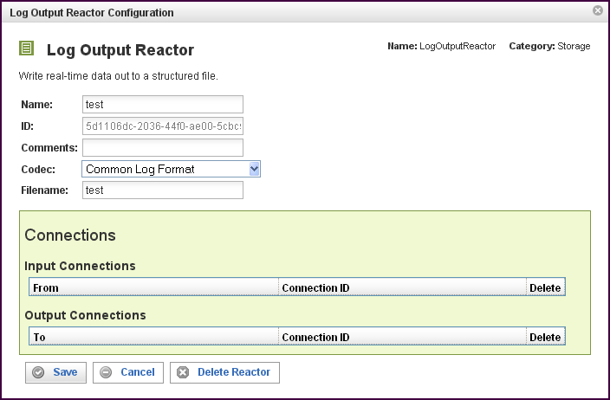

In addition to the fields you saw when adding the reactor initially (described above), you will see one additional field and the Connections section. The additional field is:
Field | Description
ID | The reactor ID, a unique ID generated by the Pion server. This ID identifies a particular reactor.

The Connections Section
The Connections section describes input and output connections for this Log Output Reactor. See “Reactor Input and Output Connections“X on page X37X for more information.

Multi Database Reactor
The Multi Database Reactor enables Pion to store data in several databases, based on the data being stored. The Multi Database Reactor stores using rotating partitions, such that the partitions for all tables are divided synchronously based upon sessionizing criteria, size and time.

When you add a Multi Database Reactor you will be prompted for the following fields:
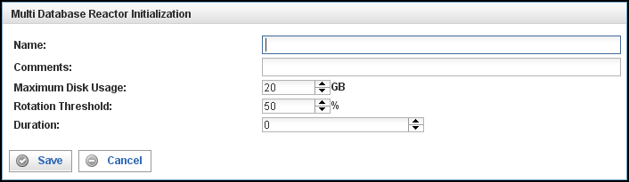

Field | Description
Name | Specify the name of this reactor. This can be any name you find descriptive, we recommend something which describes the data this reactor is processing.  The name may be any combination of letters and numbers.
Comments | Enter some descriptive comments about this reactor. Any comment you feel will help you in the future, we recommend choosing something that describes the data being stored.
Maximum Disk Usage | The number of gigabytes this particular Multi Database Reactor can use to store data.  Note: Pion makes a best effort attempt to comply with this setting, but you should expect the actual amount of space to to vary ± 10% from the specification. For example, if you specify 50GB, the server can easily use 55 GB, or it may only use 45 GB.  Note also: If you have two (or more) Multi Database Reactors, this is an individual, per-reactor setting. For example, if you have 100 GB of free space, and you have two Multi Database Reactors, you should not give more than 40 GB to each reactor (or however you want to balance it). Do not over-commit your available storage.  Regarding the size given:  - Do not commit more than 80% of your total free disk space.  - If you are using local Database Output Reactors or Log Output Reactors, remember to take into account their storage needs.
Rotation Threshold | Rotation Threshold is a measure of cache utilization, which is calculated by:  - The number of columns indexed (in the Multi Database Reactors configuration information) multiplied by size of the content of those columns.  - Adjusted for the overhead of SQLite.  - Compared to the configured database index cache size (dbengines.xml)  Rotation Threshold is expressed as a percentage:  - For high volumes of data (400Mbps), you should not exceed 50%.  - For low volumes of data (<200Mbps), you can probably go 200%.  See High-Volume Pion Implementation Guidelines. on page 15 for information on configuring Pion for high volumes of data.
Duration | The amount of time (in seconds) after which the Multi Database Reactor rotates partitions.
SessionTimeout | Specifies the number of seconds between pruning of the session cache maintained by the Multi Database Reactor. This value should always be just slightly higher than the session timeout defined in your Clickstream Reactor.
Prune Interval | Specifies how often (in seconds) the Multi Database Reactor will prune its session cache.
Session Term | The vocabulary term used to uniquely identify a visitor session (urn:vocab:clickstream#session-id).
This creates the Multi Database Reactor in the workspace. Double-clicking on the reactor brings you to the configuration screen:

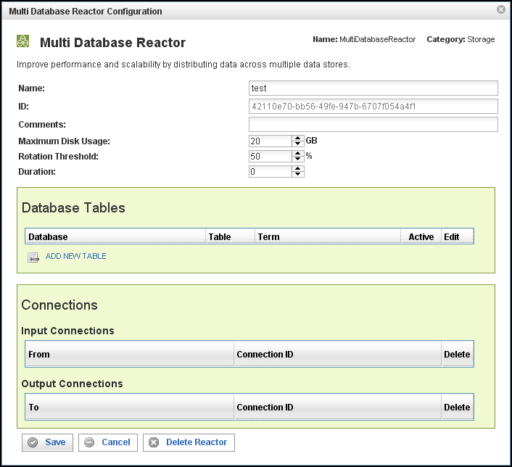
In addition to the fields you saw when adding the reactor initially (described above), you will see one additional field and the Connections section. The additional field is:
Field | Description
ID | The reactor ID, a unique ID generated by the Pion server. This ID identifies a particular reactor.

The Database Tables Section
The Database Tables section specifies what data gets stored in which databases. By specifying a database, a table within that database, and a term to be stored in that table, you control what information is stored in which database.
Note: Each Database Table is essentially a separate instance of the Database Output Reactor.
Field | Description
Database | Select the database into which you want to write events.
Table | Specify the table in the database named above. The events will be written to this table.
Term | Defines the type of event to be stored in the database and table specified above.
Active | If this check box is filled, the table is active and events of the type specified will be stored in the database and table specified above.  If this check box is empty, the table is temporarily disabled and no events will be stored.
Edit | Opens another window to specify the database field mappings and other characteristics for the table.
To delete a connection, click on the “x” at the end of the row describing that connection.

The Connections Section
The Connections section describes input and output connections for this Multi Database Reactor. See “Reactor Input and Output Connections“ on page X37X for more information.

Omniture Analytics Reactor
The Omniture Analytics Reactor is able to take web user behavior information and send it through the Omniture Genesis integration system to SiteCatalyst via its native XML web service interface in real-time. All you need to supply is the relevant account information and site name to connect Pion to Omniture.
When you add a Omniture Analytics Reactor you will be prompted for the following fields:
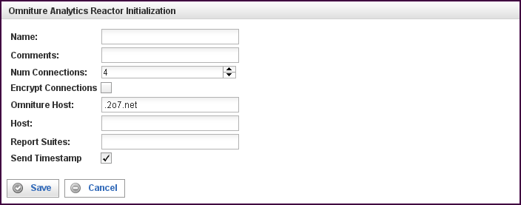

Field | Description
Name | Specify the name of this reactor. This can be any name you find descriptive, we recommend something which describes the data this reactor is processing.  The name may be any combination of letters and numbers.
Comments | Enter some descriptive comments about this reactor. Any comment you feel will help you in the future, we recommend choosing something that describes the data being stored.
Num Connections | Specify the maximum number of concurrent connections.  With Omniture; you can deliver 50 events/second with one connection. If you need higher speed (taking bursts/peaks into account), use a higher number of connections. Using a higher number of connections will use more bandwidth, and you may have to consult with Omniture to make sure that they are able to receive the traffic.  Generally, a value of 2 or 4 and up to 16 is reasonable.
Encrypt Connections (check box) | Fill this check box to encrypt connections between Pion and the Omniture Genesis host.
Omniture Host | Omniture Analytics Reactor; this is the “Omniture Host” that you get from the Omniture SiteCatalyst [check verbiage from Omniture] as the destination where all the page hits are sent for processing. Must be of the form customername.122.2o7.net or customername.112.2o7.net.  Note: The ‘o’ in 2o7 is the letter, not a zero.
Host | The Omniture Host to which your reporting is to be sent. Specified as a URI, and given by the Omniture "wizard" at the time of registering your account.  The Omniture Host URI is of the form accountid.122.2o7.net or accountid.112.2o7.net (do not try to guess it, use what Omniture supplies).
Report Suites | Check with Omniture for description of a Report Suite.  In Omniture Analytics Reactor, you would fill in ALL the Report Suites you want the page views to be delivered to. Separate multiple Report Suite names with commas.
Send Timestamp (check box) | For Omniture accounts used with Pion, you must enable time stamps (this check box should be filled).  Pion will supply the time stamps for all events (in UTC format), adjusting for the local time zone.  If you are experimenting, with an Omniture account not used with Pion, Timestamps must be set off (this check box should be empty).  Note: Only Omniture technical support can change the Timestamp setting on the Omniture account.  If the Timestamp setting does not match the Omniture back end, all events are silently dropped.
This creates the Omniture Analytics Reactor in the workspace. Double-clicking on the reactor brings you to the configuration screen:
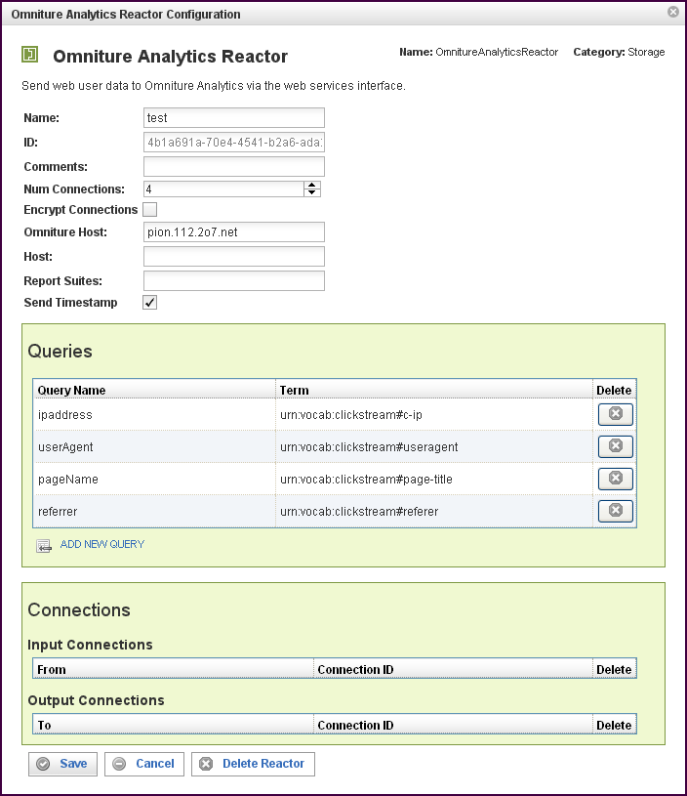

In addition to the fields you saw when adding the reactor initially (described above), you will see one additional field and the Queries and Connections sections. The additional field is:
Field | Description
ID | The reactor ID, a unique ID generated by the Pion server. This ID identifies a particular reactor.

The Queries Section
The Queries section allows you match Omniture queries with Pion terms. This matching allows you to send Pion data directly to Omniture Analytics.
Field | Description
Query Name | Select one of the available queries from the list.  In previous versions, some query terms were hard coded to “[computed]" and as such were not visible. Now, however, the "[computed]" can be overridden, with a term, but you must be sure to compute the proper value for such term.  Generally, this is *very*special* usage, most users should not attempt it. Contact Pion professional services for advice before using this functionality.  The [computed] values are:  - visitorID  Computed to be a persistent visitor ID, Omniture enforces some strict requirements on what it can be. Do not override unless confirming with Omniture what is allowed.  - server  Computed to be the "host" configuration parameter. The only time you might want to override this is if you have multiple servers, and logic programmed to determine the correct server.  - pageURL  Computed to be the PageURL, complete with http/https, port (if applicable), URL, and query parameters.  - timestamp  If applicable, computed to be the timestamp of the event, in ISO-8601 format, adjusted for Zulu timezone. For more information, see: http://en.wikipedia.org/wiki/ISO-8601.  - reportSuiteID  The same as Account ID, useful only if you are feeding multiple accounts, and have to logic to replace the Account ID  All of the parameters above will be XML_Encoded on the way out, so they should not be encoded coming in.
Term | Select the term to match with the query.
To add a row for a new query in the Queries section, click on the ADD NEW QUERY link.
To delete a query, click on the “x” at the end of the row describing that query.

The Connections Section
The Connections section describes input and output connections for this Omniture Analytics Reactor. See “Reactor Input and Output Connections“X on page X37X for more information.

